

Event zone

SOFTWARE REQUIREMENTS SPECIFICATION

**Project code: EZ**

**Document code: EZ_SoftwareRequirementsSpecification_v1.0**

変更履歴

*A - 追加 M - 修正 D – 削除

|  |  |  |  |  |  |
| --- | --- | --- | --- | --- | --- |
| 発効日 | 変更項目 | A* M, D | 変更説明 | 変更の理由 | 版数 |
| 19/9/2015 | Create New | A | Create Document |  |  |
|  |  |  |  |  |  |
|  |  |  |  |  |  |
|  |  |  |  |  |  |
|  |  |  |  |  |  |
|  |  |  |  |  |  |
|  |  |  |  |  |  |
|  |  |  |  |  |  |
|  |  |  |  |  |  |
|  |  |  |  |  |  |
|  |  |  |  |  |  |
|  |  |  |  |  |  |
|  |  |  |  |  |  |
|  |  |  |  |  |  |

署名ページ

作成者： Phan Thanh Vu 22/09/2015

Project Manager

レビュー者： Nguyen Van Cuong <Date>

<Position>

Duong Thi Lan Anh <Date>

<Position>

承認者： Tran Binh Duong <Date>

<Position>

目次

1 はじめに 7

1.1 目的 7

1.2 範囲 7

1.3 定義、頭字語および略語 8

1.4 参照資料 8

1.5 概 8

1.6 要 8

2 概要説明 9

2.1 Product Perspective 9

2.2 User Characteristics 9

2.3 Constraints 10

3 要求仕様 11

3.1 機能要求 11

3.1.1 Admin Function 14

3.1.2 Moderator Function 47

3.1.3 User Functions 66

3.2 ユーザビリティ 100

3.3 信頼性 100

3.4 性能 101

3.5 サポータビリティ 102

3.6 設計制約 102

3.7 オンラインユーザドキュメンテーション、ヘルプシステムへの要求 102

3.8 インタフェース 103

3.8.1 User Interface 103

3.8.2 Hardware Interface 118

3.8.3 Software Interface 118

3.9 適用基準 118

4 サポート情報 118

# Introduction

## Purpose

This document provides developers, testers, QAs a complete and comprehensive description of both the functional requirement and non-functional requirements of the Event Zone. Developers base on this document to develop the system, and testers base on this to assure the quality of the output system. Project manager base on this document to create schedule and assign task to team members.

## Scope

Event Zone is a website that will implement these functions:

For User:

* Search by Text or by Location:
* Manage Event:
* Follow Event:
* Follow Category:
* View Statistic:
* Report Violated Events:
* Appeal Violation Reports:
* Live Streaming by Youtube API

Out-of-scope:

* Making List Events:
* Streaming Server:
* Upload Image:
* View Schedule:
* Follow Other Users:

## Definitions, Acronyms, and Abbreviations

|  |  |  |
| --- | --- | --- |
| No | Term | Definition |
|  |  |  |
|  |  |  |

## References

|  |  |  |
| --- | --- | --- |
| No | Document | Source |
| 1 | System Requirements Specification | FPT Sofware Corporation |
|  |  |  |

## Overview

The document contains 4 part:

* Introduction: Provides basic information about the project. It include purpose, scope, definitions, acronyms, abbreviations, references, and overview.
* Overview Description: describes the general factors that affect the product and its requirements. This section does not state specific requirements. Instead, it provides a background for those requirements, which are defined in detail in Section 3, and makes them easier to understand.
* Required Specifications: contains all software requirements to a level of detail sufficient to enable designers to design a system to satisfy those requirements, and testers to test that the system satisfies those requirements.
* Support Information: supporting information makes the SRS easier to use.

# Overall description

## Product Perspective

Event industry has been growing fast since few years ago. A lot of event planner want to find more ways to attract people to event, while others people try to find event around them or event online to watch stream online.

Therefore, Event Zone was developed as a social solution to meet the demand of people. It not only help people to find event, but also help people to create their own event and support them create live streaming link.

## User Characteristics

There are 4 types of user in Event Zone.

In Front-end:

* User: People who wants to create events or find events.
* Moderators: People who controls information content.

In back-end

* Root admin: People who manages all admin.
* Admin: People who manages all system.

## Constraints

Users have to connect to Internet to use functions in website.

Users have to have at least one Google Account to use functions in website correctly.

# Required specifications

## Functional Requirements

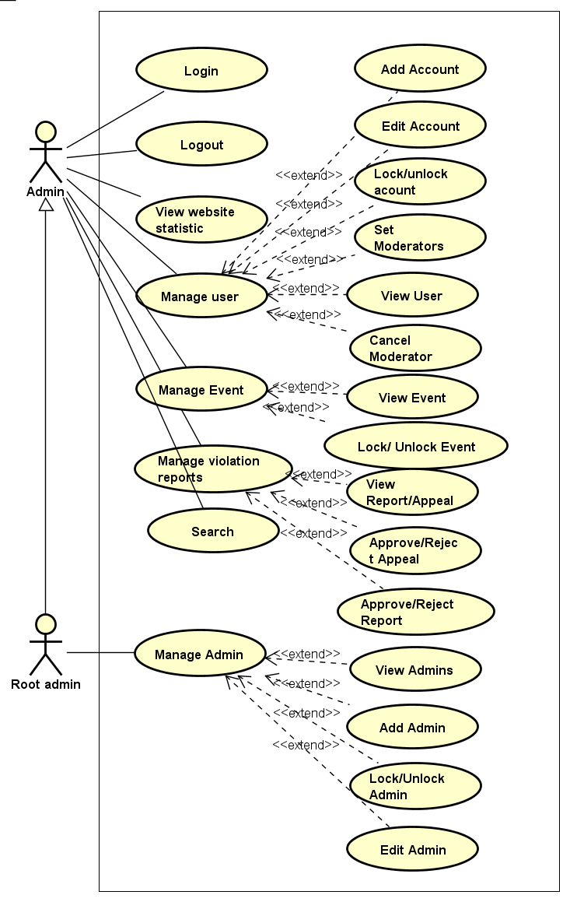

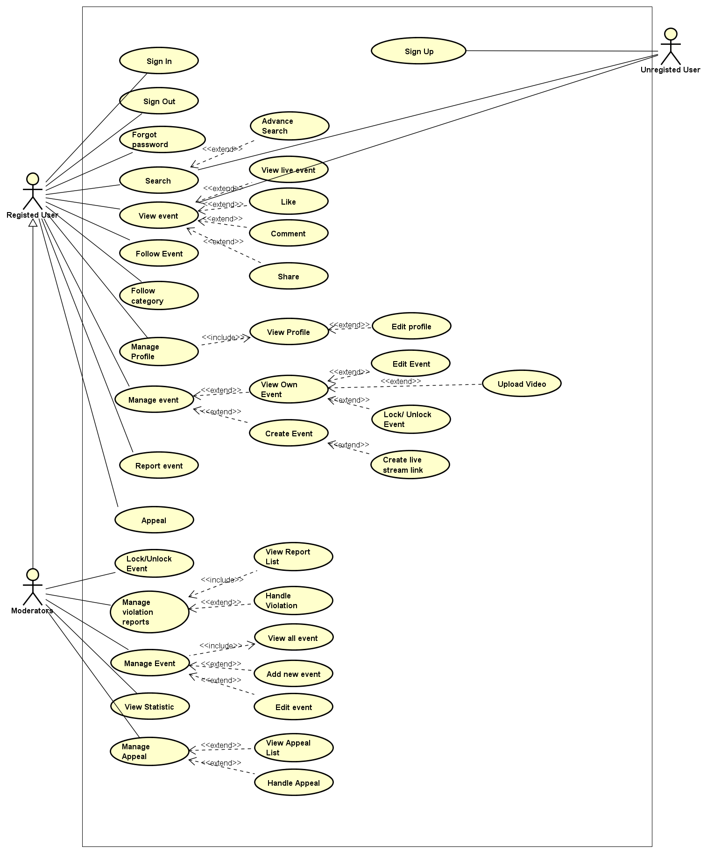

* + 1. Admin Function

#### Sign in

|  |  |  |  |  |  |
| --- | --- | --- | --- | --- | --- |
| Use Case Name | Sign in | | | | |
| Use Case ID | UC-001 | | | | |
| Created By | ChuongNT | Last Updated By | | | ChuongNT |
| Date Created | 21/09/2015 | Date Last Updated | | | 24/09/2015 |
| Actor | Admin, Root Admin | | | | |
| Goal/Description | This use case allows Actor sign in to Admin’s Management Screen | | | | |
| Pre-Condition | Actor is not sign in. System current shows Sign in Page. | | | | |
| Trigger | Actor wants to sign in | | | | |
| Post Condition | Actor signed in. System current shows Index Page. | | | | |
| Basic Path | Actor’s action | | | System’s response | |
|  | 1. Enter username and password. (E1) | | |  | |
| 1. Click on “Sign in” button | | | Redirect to Index Screen | |
| Alternative Paths |  | | | | |
| Exception Paths | E1. If user enter the wrong username, password or both | | The screen will show the notice “Username or password is incorrect!” | | |
| Notes |  | | | | |

#### Sign out

|  |  |  |  |  |
| --- | --- | --- | --- | --- |
| Use Case Name | Sign out | | | |
| Use Case ID | UC-002 | | | |
| Created By | ChuongNT | Last Updated By | | ChuongNT |
| Date Created | 21/09/2015 | Date Last Updated | | 24/09/2015 |
| Actor | Admin, Root Admin | | | |
| Goal/Description | This use case allows Actor log out system | | | |
| Pre-Condition | Actor is signed in | | | |
| Trigger | Actor wants to sign out | | | |
| Post Condition | Actor sign out of the system | | | |
| Basic Path | Actor’s action | | System’s response | |
|  | Click on “Sign out” | | Redirect to the Login Screen | |
| Alternative Paths |  | | | |
| Exception Paths |  | | | |
| Notes |  | | | |

#### Search

|  |  |  |  |  |
| --- | --- | --- | --- | --- |
| Use Case Name | Search | | | |
| Use Case ID | UC-054 | | | |
| Created By | ChuongNT | Last Updated By | | ChuongNT |
| Date Created | 21/09/2015 | Date Last Updated | | 24/09/2015 |
| Actor |  | | | |
| Goal/Description | Allow Actor find out the user information or event which match the inputted text. | | | |
| Pre-Condition | Actor is log in. | | | |
| Trigger | Actor wants to search user or event . | | | |
| Post Condition | Actor is staying on Result screen which has all matching search results. | | | |
|  | Actor’s Action | | System’s Response | |
| Basic Path | 1. Input text to the search bar | |  | |
| 1. Click on “Search” button   (A1)(E1) | | Result screen will display | |
| Alternative Paths | 2.a.Actor press “Enter” | | Result screen will display | |
| Exception Paths | E1. If Actor press “Enter” while search bar is empty. | | Show the notice “Let’s fill your text to search !” | |
| Notes |  | | | |

#### Manage Users

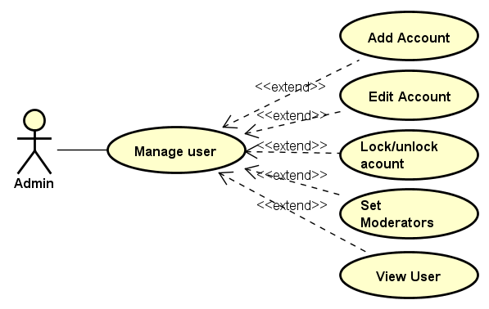

##### View Users

|  |  |  |  |  |
| --- | --- | --- | --- | --- |
| Use Case Name | View Users | | | |
| Use Case ID | UC-003 | | | |
| Created By | ChuongNT | Last Updated By | | ChuongNT |
| Date Created | 22/09/2015 | Date Last Updated | | 24/09/2015 |
| Actor | Admin, Root Admin | | | |
| Goal/Description | This use case allows actor view all users | | | |
| Pre-Condition | Actor is signed in. System current shows Manage Users Page. | | | |
| Trigger | Actor wants to view all users in Event Zone’s system. | | | |
| Post Condition | System show all user information in system | | | |
|  | Actor’s Action | | System’s Response | |
| Basic Path | Click “View Users” button | | Redirect to the View Users Screen | |
| Alternative Paths |  | |  | |
| Exception Paths |  | |  | |
| Notes |  | | | |

##### Add Account

|  |  |  |  |  |  |
| --- | --- | --- | --- | --- | --- |
| Use Case Name | Add Account | | | | |
| Use Case ID | UC-004 | | | | |
| Created By | ChuongNT | Last Updated By | | | ChuongNT |
| Date Created | 21/09/2015 | Date Last Updated | | | 24/09/2015 |
| Actor | Admin, Root Admin | | | | |
| Goal/Description | This use case allow actor create new account for users | | | | |
| Pre-Condition | Actor is signed in. System current shows Manage Users Page. | | | | |
| Trigger | Actor wants to add account | | | | |
| Post Condition | Account is added to the database. System current shows Manage Users Page. | | | | |
| Basic Path | Actor’s action | | | System’s response | |
|  | 1. Click on “Add Account” button | | | Redirect to Add Account Screen | |
| 1. Fill the information of an account to field about username and password. (E1) | | |  | |
| 1. Click on “Add” button to add an account | | | Redirect to Add Account Screen | |
| Alternative Paths |  | | | | |
| Exception Paths | (E1) | |  | | |
| * 1. If user did not enter username | | * 1. The screen will show the notice “username is not null” | | |
| * 1. If user did not enter password | | * 1. The screen will show the notice “password is not null” | | |
| * 1. If user did not re-enter password | | * 1. The screen will show the notice “re-enter password is not null” | | |
| * 1. If user re-enter password that not matched with the password above | | * 1. The screen will show the notice “password is incorrect” | | |
| Notes |  | | | | |

##### Edit Account

|  |  |  |  |  |  |
| --- | --- | --- | --- | --- | --- |
| Use Case Name | Edit Account | | | | |
| Use Case ID | UC-005 | | | | |
| Created By | ChuongNT | Last Updated By | | | ChuongNT |
| Date Created | 21/09/2015 | Date Last Updated | | | 24/09/2015 |
| Actor | Admin, Root Admin | | | | |
| Goal/Description | This use case allows actor edits information of users | | | | |
| Pre-Condition | Actor is signed in. System current shows Manage Users Page. | | | | |
| Trigger | Actor wants to edit account | | | | |
| Post Condition | Account is edited | | | | |
| Basic Path | Actor’s action | | | System’s response | |
|  | 1. Click on “Edit” button. A1 | | | Redirect to Account Screen | |
| 1. Edit the information of an account to field about username and password. E1 | | |  | |
| 1. Click on “Save” button to add an account | | | Redirect to Account Screen | |
| Alternative Paths | A1. If actor current view detail account page of an account:  Click on button edit “Edit” in the right top of account. | | | | |
| Exception Paths | E1 | |  | | |
| * 1. If username is blank | | * 1. The screen will show the notice “username is not null” | | |
| * 1. If password is blank | | 2.2 The screen will show the notice “password is not null” | | |
| * 1. If re-enter password is blank | | 2.3 The screen will show the notice “re-enter password is not null” | | |
| 2.4 If user re-enter password that not matched with the password above | | 2.4 The screen will show the notice “password is incorrect” | | |
| Notes |  | | | | |

##### Lock Account

|  |  |  |  |  |
| --- | --- | --- | --- | --- |
| Use Case Name | Lock Account | | | |
| Use Case ID | UC-006 | | | |
| Created By | ChuongNT | Last Updated By | | ChuongNT |
| Date Created | 21/09/2015 | Date Last Updated | | 22/09/2015 |
| Actor | Admin, Root Admin | | | |
| Goal/Description | This use case allows actor lock user’s account | | | |
| Pre-Condition | Actor is signed in, Account is unlocked. System current shows Manage Users Page. | | | |
| Trigger | Actor wants to lock user’s account | | | |
| Post Condition | Account is locked. System current shows Manage Users Page. If exception occur, account is unlocked. | | | |
| Basic Path | Actor’s action | | System’s response | |
|  | 1. Click on “Lock” button | | System show notice confirm lock | |
| 1. Click “Yes” button.E1 | | System send notification to account, account is locked and “Lock” button change to “Unlock” button | |
| Alternative Paths |  | | | |
| Exception Paths | E1. If actor click “No” button system back to Manage Users Page | | | |
| Notes |  | | | |

##### Unlock Account

|  |  |  |  |  |
| --- | --- | --- | --- | --- |
| Use Case Name | Unlock Account | | | |
| Use Case ID | UC-007 | | | |
| Created By | ChuongNT | Last Updated By | | ChuongNT |
| Date Created | 21/09/2015 | Date Last Updated | | 22/09/2015 |
| Actor | Admin, Root Admin | | | |
| Goal/Description | This use case allows actor unlock user’s account | | | |
| Pre-Condition | Actor is signed in, Account is locked. System current shows Manage Users Page. | | | |
| Trigger | Actor wants to unlock user’s account | | | |
| Post Condition | Account is unlocked. System current shows Manage Users Page. If exception occur, account is locked. | | | |
| Basic Path | Actor’s action | | System’s response | |
|  | 1. Click on “ Unlock” button | | System show notice confirm unlock | |
| 1. Click “Yes” button.E1 | | System send notification to account, account is unlocked and “Unlock” button change to “Lock” button | |
| Alternative Paths |  | | | |
| Exception Paths | E1. If actor click “No” button system back to Manage Users Page | | | |
| Notes |  | | | |

##### Set Moderator

|  |  |  |  |  |
| --- | --- | --- | --- | --- |
| Use Case Name | Set Moderator | | | |
| Use Case ID | UC-008 | | | |
| Created By | ChuongNT | Last Updated By | | ChuongNT |
| Date Created | 21/09/2015 | Date Last Updated | | 22/09/2015 |
| Actor | Admin, Root Admin | | | |
| Goal/Description | This use case allows actor set user account to Moderator | | | |
| Pre-Condition | Admin is signed in. Account is not Moderator. System current shows Manage Users Page. | | | |
| Trigger | Actor wants to set Moderator for user account | | | |
| Post Condition | Account is set Moderator. System current shows Manage Users Page. If exception occur, account is not set to Moderator. | | | |
| Basic Path | Actor’s action | | System’s response | |
|  | 1. Click on “Set Moderator” button | | System show notice confirm set Moderator | |
| 1. Click “Yes” button.E1 | | System send notification to account, account is Moderator and “Set Moderator” button change to “Cancel Moderator” button | |
| Alternative Paths |  | | | |
| Exception Paths | E1. If actor click “No” button system back to Manage Users Page | | | |
| Notes |  | | | |

##### Cancel Moderator

|  |  |  |  |  |
| --- | --- | --- | --- | --- |
| Use Case Name | Set Moderator | | | |
| Use Case ID | UC-009 | | | |
| Created By | ChuongNT | Last Updated By | | ChuongNT |
| Date Created | 21/09/2015 | Date Last Updated | | 22/09/2015 |
| Actor | Admin, Root Admin | | | |
| Goal/Description | This use case allows actor change Moderator to user account | | | |
| Pre-Condition | Admin is signed in. Account is Moderator. System current shows Manage Users Page. | | | |
| Trigger | Actor wants to set Moderator to user account | | | |
| Post Condition | Account is user. System current shows Manage Users Page. If exception occur, account is Moderator. | | | |
| Basic Path | Actor’s action | | System’s response | |
|  | 1. Click on “Cancel Moderator” button | | System show notice confirm Cancel Moderator | |
| 1. Click “Yes” button.E1 | | System send notification to account, account is user and “Cancel Moderator” button change to “Set Moderator” button | |
| Alternative Paths |  | | | |
| Exception Paths | E1. If actor click “No” button system back to Manage Users Page | | | |
| Notes |  | | | |

#### View Statistic

|  |  |  |  |  |
| --- | --- | --- | --- | --- |
| Use Case Name | View Statistic | | | |
| Use Case ID | UC-010 | | | |
| Created By | ChuongNT | Last Updated By | | ChuongNT |
| Date Created | 21/09/2015 | Date Last Updated | | 24/09/2015 |
| Actor | Admin, Root Admin | | | |
| Goal/Description | This use case allows actor view Statistic of website | | | |
| Pre-Condition | Actor is signed in. System current shows Index Page. | | | |
| Trigger | Actor wants to view statistic | | | |
| Post Condition | View statistic screen is displayed. System current shows View Statistic Page. | | | |
| Basic Path | Actor’s action | | System’s response | |
|  | 1. Click on “View Statistic” button | | Redirect to View Statistic screen | |
| Alternative Paths |  | | | |
| Exception Paths |  | | | |
| Notes |  | | | |

#### Manage Event

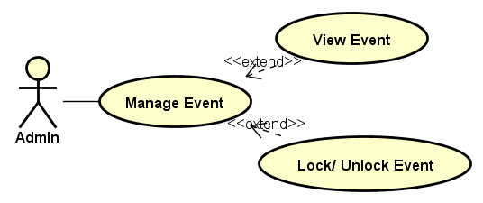

##### View Event:

|  |  |  |  |  |
| --- | --- | --- | --- | --- |
| Use Case Name | View Event | | | |
| Use Case ID | UC-011 | | | |
| Created By | ChuongNT | Last Updated By | | ChuongNT |
| Date Created | 21/09/2015 | Date Last Updated | | 24/09/2015 |
| Actor | Admin, Root Admin | | | |
| Goal/Description | This use case allows actor View Event of website | | | |
| Pre-Condition | Actor is signed in. System current shows Manage Event Page. | | | |
| Trigger | Actor wants to view event | | | |
| Post Condition | View Event screen is displayed. System current shows  View Event Page. | | | |
| Basic Path | Actor’s action | | System’s response | |
|  | 1. Click on “View Events” button | | Redirect to View Event screen | |
| Alternative Paths |  | | | |
| Exception Paths |  | | | |
| Notes |  | | | |

##### Lock Event

|  |  |  |  |  |
| --- | --- | --- | --- | --- |
| Use Case Name | Lock Event | | | |
| Use Case ID | UC-012 | | | |
| Created By | ChuongNT | Last Updated By | | ChuongNT |
| Date Created | 21/09/2015 | Date Last Updated | | 22/09/2015 |
| Actor | Admin, Root Admin | | | |
| Goal/Description | This use case allows actor lock event | | | |
| Pre-Condition | Actor is signed in, event is unlocked. System current shows Manage Event Page. | | | |
| Trigger | Actor wants to lock event | | | |
| Post Condition | Event is locked. System current shows Manage Event Page. If exception occur, event is unlocked. | | | |
| Basic Path | Actor’s action | | System’s response | |
|  | 1. Click on “ Lock” button | | System show notice confirm lock | |
| 1. Click “Yes” button.E1 | | System send notification to account, event is locked, event is not displayed on website and “Lock” button change to “Unlock” button | |
| Alternative Paths |  | | | |
| Exception Paths | E1. If actor click “No” button system back to Manage Event Page | | | |
| Notes |  | | | |

##### Unlock Event

|  |  |  |  |  |
| --- | --- | --- | --- | --- |
| Use Case Name | Unlock Event | | | |
| Use Case ID | UC-013 | | | |
| Created By | ChuongNT | Last Updated By | | ChuongNT |
| Date Created | 21/09/2015 | Date Last Updated | | 22/09/2015 |
| Actor | Admin, Root Admin | | | |
| Goal/Description | This use case allows actor unlock event | | | |
| Pre-Condition | Actor is signed in, Event is locked. System current shows Manage Event Page. | | | |
| Trigger | Actor wants to unlock event | | | |
| Post Condition | Event is unlocked. System current shows Manage Event Page. If exception occur, event is locked. | | | |
| Basic Path | Actor’s action | | System’s response | |
|  | 1. Click on “ Unlock” button | | System show notice confirm unlock | |
| 1. Click “Yes” button.E1 | | System send notification to account, event is unlocked and “Unlock” button change to “Lock” button | |
| Alternative Paths |  | | | |
| Exception Paths | E1. If actor click “No” button system back to Manage Event Page | | | |
| Notes |  | | | |

#### Manage Violation Report

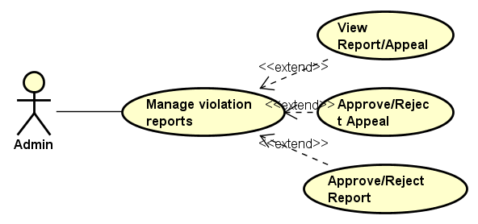

##### View Report/Appeal

|  |  |  |  |  |
| --- | --- | --- | --- | --- |
| Use Case Name | View Report/Appeal | | | |
| Use Case ID | UC-014 | | | |
| Created By | ChuongNT | Last Updated By | | ChuongNT |
| Date Created | 22/09/2015 | Date Last Updated | | 23/09/2015 |
| Actor | Admin, Root Admin | | | |
| Goal/Description | This use case allows Actor view all report | | | |
| Pre-Condition | Actor is signed in. System current shows Manage Violation Report Page. | | | |
| Trigger | Actor wants to view all report in Event Zone’s system. | | | |
| Post Condition | Actor can view all users. System current shows View Violation Report Page. | | | |
|  | Actor’s Action | | System’s Response | |
| Basic Path | 1. Click “View Report” button | | Redirect to the View Report Screen | |
| Alternative Paths |  | |  | |
| Exception Paths |  | |  | |
| Notes |  | | | |

##### Handle Report

|  |  |  |  |  |  |
| --- | --- | --- | --- | --- | --- |
| Use Case Name | Handle Report | | | | |
| Use Case ID | UC-015 | | | | |
| Created By | ChuongNT | Last Updated By | | | ChuongNT |
| Date Created | 22/09/2015 | Date Last Updated | | | 22/09/2015 |
| Actor | Admin, Root Admin | | | | |
| Goal/Description | This use case allows Actor handles user’s report. | | | | |
| Pre-Condition | Actor is signed in. System current shows Manage Violation Report Page. | | | | |
| Trigger | Actor wants to handle report. | | | | |
| Post Condition | Report status is updated. System current shows Manage Violation Report Page. If exception occur, system response based on exception. | | | | |
| Basic Path | Actor’s Action | | | System’s response | |
|  | 1. Actor selects a pending report from list report. | | | Redirects to view report detail. | |
| 1. Actor select and click on button in action area(): | | |  | |
| * + Actor click on button “Approve” | | | * + System change report status to “Approved”. | |
| * + Actor click on button “Reject” | | | * + System change report to status “Rejected” | |
|  | 1. Actor click on button “Save”(E1) | | | System update report and save to database. System informs to user that handling successful and redirect to Manage reports page. | |
| Alternative Paths |  | | | | |
| Exception Paths | E1. Actor wants to cancel handling report: | | | | |
|  | Actor’s Action | | System’s response | | |
|  | 3.1 Actor click on button “Cancel” | | System displays exit handling report confirmation pop-up. | | |
| Notes | There are 3 status of report:   * “Pending” report: report is not handled. * “Approved” report: report is determined that the information given in the report is exactly and it must be handle. * “Reject” report: report determined that the information given in the report is not true and it will be ignore. | | | | |

##### Handle Appeal

|  |  |  |  |  |  |
| --- | --- | --- | --- | --- | --- |
| Use Case Name | Handle Report | | | | |
| Use Case ID | UC-016 | | | | |
| Created By | ChuongNT | Last Updated By | | | ChuongNT |
| Date Created | 22/09/2015 | Date Last Updated | | | 22/09/2015 |
| Actor | Admin, Root Admin | | | | |
| Goal/Description | This use case allows Actor handles user’s appeal. | | | | |
| Pre-Condition | Actor is signed in. System current shows Manage Violation Report Page. | | | | |
| Trigger | Actor wants to handles appeals. | | | | |
| Post Condition | Appeal status is updated. System current shows Manage Violation Report Page. If exception occur, system response based on exception. | | | | |
| Basic Path | Actor’s Action | | | System’s response | |
|  | 1. Actor selects a pending appeal from list appeal. | | | Redirects to view appeal detail. | |
| 1. Actor select and click on button in action area(): | | |  | |
| * + Actor click on button “Approve” | | | * + System change appeal status to “Approved”. | |
| * + Actor click on button “Reject” | | | * + System change appeal to status “Rejected” | |
|  | 1. Actor click on button “Save”(E1) | | | System update appeal and save to database. System informs to user that handling successful and redirect to Manage Violation Report page. | |
| Alternative Paths |  | | | | |
| Exception Paths | E1. Actor wants to cancel handling appeal: | | | | |
|  | Actor’s Action | | System’s response | | |
|  | 3.1 Actor click on button “Cancel” | | System displays exit handling appeal confirmation pop-up. | | |
| Notes | There are 3 status of appeal:   * “Pending” appeal: appeal is not handled. * “Approved” appeal: appeal is determined that the information given in the appeal is exactly and it must be handle. * “Reject” appeal: appeal determined that the information given in the appeal is not true and it will be ignore. | | | | |

#### Manage Admin

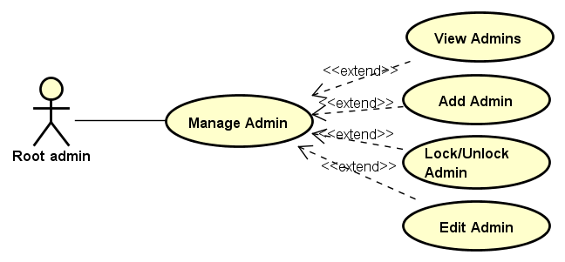

##### View Admins

|  |  |  |  |  |
| --- | --- | --- | --- | --- |
| Use Case Name | View Admins | | | |
| Use Case ID | UC-017 | | | |
| Created By | ChuongNT | Last Updated By | | ChuongNT |
| Date Created | 21/09/2015 | Date Last Updated | | 22/09/2015 |
| Actor | Root Admin | | | |
| Goal/Description | This use case allows Actor view all admins | | | |
| Pre-Condition | Actor is signed in. System current shows Manage Admin Page. | | | |
| Trigger | Actor wants to view all admins | | | |
| Post Condition | View Admin screen is displayed. System current shows Manage Admin Page. | | | |
| Basic Path | Actor’s action | | System’s response | |
|  | 1. Click on “View Admin” button | | Redirect to View Admin screen | |
| Alternative Paths |  | | | |
| Exception Paths |  | | | |
| Notes |  | | | |

##### Add Admin

|  |  |  |  |  |  |
| --- | --- | --- | --- | --- | --- |
| Use Case Name | Add Admin | | | | |
| Use Case ID | UC-018 | | | | |
| Created By | ChuongNT | Last Updated By | | | ChuongNT |
| Date Created | 21/09/2015 | Date Last Updated | | | 22/09/2015 |
| Actor | Root Admin | | | | |
| Goal/Description | This use case allows actor create new admin account | | | | |
| Pre-Condition | Actor is signed in. System current shows Manage Admin Page. | | | | |
| Trigger | Actor wants to create new admin account | | | | |
| Post Condition | Admin account added to the database. System current shows Manage Admin Page. | | | | |
| Basic Path | Actor’s action | | | System’s response | |
|  | 1. Click on “Add Admin” button | | | Redirect to Add Admin Screen | |
| 1. Fill the information of an account to field about username and password. E1 | | |  | |
| 1. Click on “Add” button to add an account | | | Redirect to Add Admin Screen | |
| Alternative Paths |  | | | | |
| Exception Paths | E1. | |  | | |
| * 1. If user did not enter username | | * 1. The screen will show the notice “username is not null” | | |
| * 1. If user did not enter password | | * 1. The screen will show the notice “password is not null” | | |
| * 1. If user did not re-enter password | | * 1. The screen will show the notice “re-enter password is not null” | | |
| * 1. If user re-enter password that not matched with the password above | | * 1. The screen will show the notice “password is incorrect” | | |
| Notes |  | | | | |

##### Edit Admin

|  |  |  |  |  |  |
| --- | --- | --- | --- | --- | --- |
| Use Case Name | Edit Admin | | | | |
| Use Case ID | UC-019 | | | | |
| Created By | ChuongNT | Last Updated By | | | ChuongNT |
| Date Created | 21/09/2015 | Date Last Updated | | | 22/09/2015 |
| Actor | Root Admin | | | | |
| Goal/Description | This use case allows actor edit information of Admin account | | | | |
| Pre-Condition | Actor is signed in | | | | |
| Trigger | Actor wants to edit admin information. | | | | |
| Post Condition | Admin account is edited | | | | |
| Basic Path | Actor’s action | | | System’s response | |
|  | 1. Click on “Edit” button.A1 | | | 1. Redirect to Edit Admin Screen | |
| 1. Edit the information of an account to field about username and password. E1 | | |  | |
| 1. Click on “Save” button to add an account | | | 1. Redirect to Edit Admin Screen | |
| Alternative Paths | A1. If actor current view detail admin page of an admin:  Click on button edit “Edit” in the right top of admin. | | | | |
| Exception Paths | E1 | |  | | |
| 2.1 If username is blank | | 2.1 The screen will show the notice “username is not null” | | |
| 2.2 If password is blank | | 2.2 The screen will show the notice “password is not null” | | |
| 2.3 If re-enter password is blank | | 2.3 The screen will show the notice “re-enter password is not null” | | |
| 2.4 If user re-enter password that not matched with the password above | | 2.4 The screen will show the notice “password is incorrect” | | |
| Notes |  | | | | |

##### Lock Admin

|  |  |  |  |  |
| --- | --- | --- | --- | --- |
| Use Case Name | Lock Admin | | | |
| Use Case ID | UC-020 | | | |
| Created By | ChuongNT | Last Updated By | | ChuongNT |
| Date Created | 21/09/2015 | Date Last Updated | | 24/09/2015 |
| Actor | Root Admin | | | |
| Goal/Description | This use case allow actor lock admin | | | |
| Pre-Condition | Actor is signed in, Admin is unlocked. System current shows Manage Admin Page. | | | |
| Trigger | Actor wants to lock admin | | | |
| Post Condition | Admin is locked. System current shows Manage Admin Page. If exception occur, admin account is unlocked. | | | |
| Basic Path | Actor’s action | | System’s response | |
|  | 1. Click on “Lock” button | | System show notice confirm lock | |
| 1. Click “Yes” button.E1 | | Admin is locked, “Lock” button change to “Unlock” button | |
| Alternative Paths |  | | | |
| Exception Paths | E1. If actor click “No” button system back to Manage Admin Page | | | |
| Notes |  | | | |

##### Unlock Admin

|  |  |  |  |  |
| --- | --- | --- | --- | --- |
| Use Case Name | Unlock Admin | | | |
| Use Case ID | UC-021 | | | |
| Created By | ChuongNT | Last Updated By | | ChuongNT |
| Date Created | 21/09/2015 | Date Last Updated | | 24/09/2015 |
| Actor | Root Admin | | | |
| Goal/Description | This use case allow actor unlock Admin | | | |
| Pre-Condition | Actor is signed in, Admin is locked. System current shows Manage Admin Page. | | | |
| Trigger | Actor wants to unlock admin | | | |
| Post Condition | Event is unlocked. System current shows Manage Admin Page. If exception occur, admin is locked. | | | |
| Basic Path | Actor’s action | | System’s response | |
|  | 1. Click on “ Unlock” button | | System show notice confirm unlock | |
| 1. Click “Yes” button.E1 | | Admin is unlock, “Unlock” button change to “Lock” button | |
| Alternative Paths |  | | | |
| Exception Paths | E1. If actor click “No” button system back to Manage Admin Page | | | |
| Notes |  | | | |

* + 1. Moderator Function

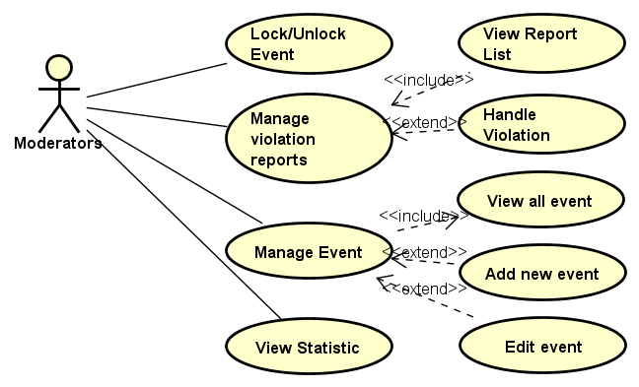

#### Manage Event

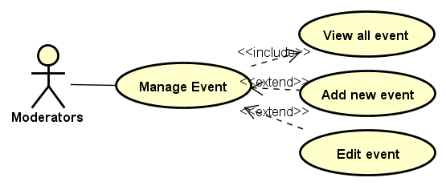

##### View All Event

|  |  |  |  |  |
| --- | --- | --- | --- | --- |
| Use Case Name | View All Event | | | |
| Use Case ID | UC-022 | | | |
| Created By | CuongNV | Last Updated By | | CuongNV |
| Date Created | 22/09/2015 | Date Last Updated | | 22/09/2015 |
| Actor | Moderators | | | |
| Goal/Description | This use case allow Moderator views all events in system. | | | |
| Pre-Condition | Moderator logs in to Event Zone. | | | |
| Trigger | Moderator wants to view all events in Event Zone’s system. | | | |
| Post Condition | System redirects to Manage Event Page and shows all event in the system | | | |
| Basic Path | Actor’s Action | | System’s response | |
|  | 1. Actor click on button C:\Users\Itachi\AppData\Local\Microsoft\Windows\INetCache\Content.Word\download.png in the right top website | | Shows user’s Menu | |
| 1. Actor click on Manage Event | | Redirects to Manage Event Page, and shows all events in the system | |
| Alternative Paths | N/A | | | |
| Exception Paths | N/A | | | |
| Notes |  | | | |

##### Edit Event

|  |  |  |  |  |  |
| --- | --- | --- | --- | --- | --- |
| Use Case Name | Edit Event | | | | |
| Use Case ID | UC-023 | | | | |
| Created By | CuongNV | Last Updated By | | | CuongNV |
| Date Created | 22/09/2015 | Date Last Updated | | | 24/09/2015 |
| Actor | Moderators | | | | |
| Goal/Description | This use case allow Moderator edits content of user’s event. | | | | |
| Pre-Condition | Actor logins website as Moderators. System current shows an event or list of events in current screen. | | | | |
| Trigger | Moderator want to edit user’s event in Event Zone’s system. | | | | |
| Post Condition | System redirect to view detail event page of edited event. | | | | |
| Basic Path | Actor’s Action | | | System’s response | |
|  | 1. Actor click on button “Edit” in the right top of event’s thumbnail in the current screen.(A1) | | | Redirects to edit’s event page. | |
| 1. Actor updates fields of event and click on button “Save” (E1) (E2) | | | System displays edit confirmation pop-up. | |
|  | 1. Actor select button “Yes”(A2) | | | System update fields of event and save to database. System also determines that this event is last edited by this actor. System informs to user that update successful and redirect to view detail event page of edited event. | |
| Alternative Paths | A1. If actor current view detail event page of an event :  Click on button edit “Edit” in the right top of event. | | | | |
| Exception Paths | E1. Actor wants to cancel edit: | | | | |
| Actor’s Action | | System’s response | | |
| 2.1 Actor click on button “Cancel” | | System displays confirmation exit edit box. | | |
| 3.1 Actor select button “Yes” | | System redirect to previous page of actor. | | |
| E2. If system determines that actor filled invalid input :   * If event title textbox is null, screen shows the notice “Event Title cannot empty”. * If event location textbox is null, screen shows the notice “Event Location cannot empty”. | | | | |
|  | A3.If actor determines want to refill edited fields : | | | | |
|  | Actor select button “No” | | Pop-up is closed. | | |
|  | Return to step 2. | |  | | |
| Notes |  | | | | |

##### Add New Event

|  |  |  |  |  |  |
| --- | --- | --- | --- | --- | --- |
| Use Case Name | Add New Event | | | | |
| Use Case ID | UC-023 | | | | |
| Created By | CuongNV | Last Updated By | | | CuongNV |
| Date Created | 22/09/2015 | Date Last Updated | | | 24/09/2015 |
| Actor | Moderator | | | | |
| Goal/Description | This use case allow Moderator adds an verify event. | | | | |
| Pre-Condition | Actor signed in to website as Moderator. Actor current access to the Manage event page. | | | | |
| Trigger | Actor determines add verify event. | | | | |
| Post Condition | New event is created in database. System redirect to view detail event page of new event. | | | | |
|  | Actor’s Action | | | System’s Response | |
| Basic Path | 1. Click to button Add new event | | | Redirect to mod’s add new event page. | |
| 1. Fill all mandatory fields and click on button “Create” (E1) (E2) | | | System displays add new event confirmation pop-up. | |
| 1. Actor select button “Yes”(E3) | | | System save new event to database. System informs to Actor that add new event successful and redirect to view detail event page new event. | |
| Alternative Paths | N/A | | | | |
| Exception Paths | E1. Actor wants to cancel add new event: | | | | |
| Actor’s Action | | | System’s response | |
| 2.1 Actor click on button “Cancel” | | | System displays exit add new event confirmation pop-up. | |
|  | 3.1 Actor select button “Yes” | | | System redirect to Manage event page. | |
|  | E2. If system determines that actor filled invalid input :   * If event title textbox is null or contain non-alphabet characters or non-number, system shows notice “Event title cannot empty and must be contain only alphabet or number character.” * If Event’s start date is null, system shows notice “Event’s start date cannot empty” * If event’s location is null, system show notice “Event’s location cannot empty” * If actor select option create live stream but his/her YouTube account is not verified account, system shows notice “Your YouTube account must be verified account to use create live stream feature”. | | | | |
|  | E3. If actor determines want to refill fields :: | | | | |
|  | Actor select button “No” | | Pop-up is closed. | | |
|  | Return to step 2. | |  | | |
| Notes |  | | | | |

#### Manage Violation Report

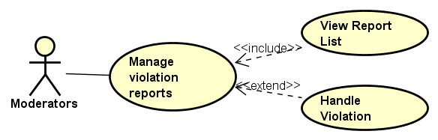

##### View Report List

|  |  |  |  |  |
| --- | --- | --- | --- | --- |
| Use Case Name | View Report List | | | |
| Use Case ID | UC-024 | | | |
| Created By | CuongNV | Last Updated By | | CuongNV |
| Date Created | 22/09/2015 | Date Last Updated | | 23/09/2015 |
| Actor | Moderator | | | |
| Goal/Description | This use case allow Moderator views all violation reports in system. | | | |
| Pre-Condition | Actor signed in to website as Moderator. | | | |
| Trigger | Actor wants to view all reports in the system. | | | |
| Post Condition | System redirects to Manage Report Page and shows all reports in the system | | | |
|  | Actor’s Action | | System’s Response | |
| Basic Path | 1. Actor click on button C:\Users\Itachi\AppData\Local\Microsoft\Windows\INetCache\Content.Word\download.png in the right top website | | Shows user’s Menu | |
| 1. Actor click on Manage Report | | Redirects to Manage Reports Page, and shows all events in the system | |
| Alternative Paths | N/A | | | |
| Exception Paths | N/A | | | |
| Notes |  | | | |

##### Handle Violation Report

|  |  |  |  |  |
| --- | --- | --- | --- | --- |
| Use Case Name | Handle Violation Report | | | |
| Use Case ID | UC-025 | | | |
| Created By | CuongNV | Last Updated By | | CuongNV |
| Date Created | 22/09/2015 | Date Last Updated | | 23/09/2015 |
| Actor | Moderators | | | |
| Goal/Description | This use case allow Moderator handles user’s report. | | | |
| Pre-Condition | Actor logins website as Moderators. System current shows Manage Reports Page. | | | |
| Trigger | Moderator want to handle violation report in Event Zone’s system. | | | |
| Post Condition | System changes report status and reloads the report’s detail page. | | | |
| Basic Path | Actor’s Action | | System’s response | |
|  | 1. Actor selects a pending report from list report. | | Redirects to view report detail. | |
| 1. Actor click on button “Approve” in the report(A1)(E1) | | System change report status to “Approved” and hidden both button “Approve” and “Reject”. System sends message to report’s sender that his action is approved, and inform to report’s receiver that his event violate system’s privacy. Violation event which is reported in this report is locked. The report’s detail page is reloaded. | |
| Alternative Paths | A1. Actor click on button “Reject” in the report | | | |
|  | 2.1. Actor click on button “Reject” in the report | | System change report status to “Reject” and hidden both button “Approve” and “Reject”. System sends message to report’s sender that his action is rejected. The report’s detail page is reloaded. | |
|  |  | |  | |
| Exception Paths | E1. Actor wants to cancel handling report: | | | |
| Actor’s Action | | System’s response | |
| 2.1 Actor click on button “Back to violation report list” | | Redirect to Manage violation reports page. | |
| Notes | There are 3 status of report:   * “Pending” report: report is not handled. * “Approved” report: report is determined that the information given in the report is exactly and it must be handle. * “Reject” report: report determined that the information given in the report is not true and it will be ignore. | | | |

#### Manage Appeal

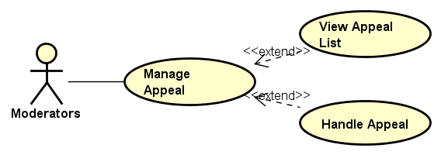

##### View Appeal List

|  |  |  |  |  |
| --- | --- | --- | --- | --- |
| Use Case Name | View Appeal List | | | |
| Use Case ID | UC-026 | | | |
| Created By | CuongNV | Last Updated By | | CuongNV |
| Date Created | 23/09/2015 | Date Last Updated | | 23/09/2015 |
| Actor | Moderator | | | |
| Goal/Description | This use case allow Moderator views all appeals of reports in system. | | | |
| Pre-Condition | Actor signed in to website as Moderator. | | | |
| Trigger | Actor wants to view all reports in the system. | | | |
| Post Condition | System redirects to Manage Appeal Page and shows all appeal in the system | | | |
| Basic Path | Actor’s Action | | System’s Response | |
| 1. Actor click on button C:\Users\Itachi\AppData\Local\Microsoft\Windows\INetCache\Content.Word\download.png in the right top website | | Shows user’s Menu | |
| 1. Actor click on Manage Appeal | | Redirects to Manage Appeal Page, and shows all appeal in the system | |
| Alternative Paths | N/A | | | |
| Exception Paths | N/A | | | |
| Notes |  | | | |

##### Handle Appeal

|  |  |  |  |  |  |
| --- | --- | --- | --- | --- | --- |
| Use Case Name | HandleAppeal | | | | |
| Use Case ID | UC-027 | | | | |
| Created By | CuongNV | Last Updated By | | | CuongNV |
| Date Created | 23/09/2015 | Date Last Updated | | | 23/09/2015 |
| Actor | Moderator | | | | |
| Goal/Description | This use case allow Moderator handle appeal of reports in system. | | | | |
| Pre-Condition | Actor logins website as Moderators. System current shows Manage Appeal Page. | | | | |
| Trigger | Moderator want to handle appeal in Event Zone’s system. | | | | |
| Post Condition | System updates appeal’s status and reported event’s status, reload appeal’s detail page. | | | | |
| Basic Path | Actor’s Action | | | System’s Response | |
| 1. Actor selects pending appeal from list appeal. | | | Redirects to view appeal detail. | |
| 1. Actor click on button “Approve” in the report(A1)(E1) | | | System change report status to “Approved” and hidden both button “Approve” and “Reject”. System sends message to appeal’s sender that his action is approved. Reported event which is related to this appeal is set to unlocked. The appeal’s detail page is reloaded. | |
| Alternative Paths | A1. Actor click on button “Reject” in the appeal | | | | |
| 2.1. Actor click on button “Reject” in the appeal | | System change appeal status to “Reject” and hidden both button “Approve” and “Reject”. System sends message to appeal’s sender that his action is rejected. The appeal’s detail page is reloaded. | | |
| Exception Paths | E1. Actor wants to cancel handling report: | | | | |
| Actor’s Action | | System’s response | | |
| 2.1 Actor click on button “Back to appeal list” | | Redirect to Manage appeal page. | | |
| Notes |  | | | | |

#### View Statistic

|  |  |  |  |  |
| --- | --- | --- | --- | --- |
| Use Case Name | View Statistic | | | |
| Use Case ID | UC-028 | | | |
| Created By | CuongNV | Last Updated By | | CuongNV |
| Date Created | 22/09/2015 | Date Last Updated | | 22/09/2015 |
| Actor | Moderator | | | |
| Goal/Description | This use case allow Moderators view statistics about their actions in website, overview about number of users, video, reports… | | | |
| Pre-Condition | Actor signed in to website as Moderator. | | | |
| Trigger | Actor want to view his/her actions in website, view overall website. | | | |
| Post Condition | The system show graphs and statistics about website and record of Moderator’s actions. | | | |
| Basic Path | Actor’s Action | | System’s Response | |
| 1. Actor click on button C:\Users\Itachi\AppData\Local\Microsoft\Windows\INetCache\Content.Word\download.png in the right top website | | Shows user’s Menu | |
| 1. Actor click on View Statistic | | Redirects to View Statistic Page, and shows all overall statistics of the website via graph and numbers. | |
| Alternative Paths | N/A | | | |
| Exception Paths | N/A | | | |
| Notes |  | | | |

#### Lock

|  |  |  |  |  |
| --- | --- | --- | --- | --- |
| Use Case Name | Lock event | | | |
| Use Case ID | UC-029 | | | |
| Created By | DuongNN | Last Updated By | |  |
| Date Created | 22/09/2015 | Date Last Updated | |  |
| Actor | Registed User | | | |
| Goal/Description | Allow user Lock an event. | | | |
| Pre-Condition | User is at Watch Events Screen | | | |
| Trigger | User wants to Lock an event. | | | |
| Post Condition | Event is Lock sucessfully. | | | |
| Basic Path | Member’s Action | | System’s Response | |
|  | 1. Click on “More” button | | A dropdown group of button is shown | |
| 1. Click on “Lock event” butotn | | A popup is shown to confirm the Lock action: “This event will be Locked. Are you sure?” including 2 button “Yes/No” | |
| * 1. Click on “Yes” button | | Redirect to Watch Event screen, screen will show a notice: “Event is set to Private.” | |
| Alternative Paths |  | |  | |
| Exception Paths | 3.2 Click on “No” button | | Redirect to Watch Event screen, popup is closed. | |
| Notes |  | | | |

#### Unlock Event

|  |  |  |  |  |
| --- | --- | --- | --- | --- |
| Use Case Name | Unlock event | | | |
| Use Case ID | UC-030 | | | |
| Created By | DuongNN | Last Updated By | |  |
| Date Created | 22/09/2015 | Date Last Updated | |  |
| Actor | Registed User | | | |
| Goal/Description | Allow user Unlock an event. | | | |
| Pre-Condition | User is at Watch Events Screen | | | |
| Trigger | User wants to Unlock an event. | | | |
| Post Condition | Event is Unlock sucessfully. | | | |
| Basic Path | Member’s Action | | System’s Response | |
|  | 1. Click on “More” button | | A dropdown group of button is shown | |
| 1. Click on “Lock event” butotn | | A popup is shown to confirm the Unlock action: “This event will be Unlocked. Are you sure?” including 2 button “Public/Unlisted” | |
| * 1. Click on “Yes” button | | Redirect to Watch Event screen, screen will show a notice: “Event is set to Public/Unlisted.” | |
| Alternative Paths |  | |  | |
| Exception Paths | 3.2 Click on “No” button | | Redirect to Watch Event screen, popup is closed. | |
| Notes |  | | | |

* + 1. User Functions

#### Sign In

|  |  |  |  |  |  |
| --- | --- | --- | --- | --- | --- |
| Use Case Name | Sign in | | | | |
| Use Case ID | UC-031 | | | | |
| Created By | HaNS02665 | Last Updated By | | | HaNS02665 |
| Date Created | 21/9/2015 | Date Last Updated | | | 22/9/2015 |
| Actor | Registed User,Moderators | | | | |
| Goal/Description | Allow user can sign in to the system | | | | |
| Pre-Condition | User has registered account | | | | |
| Trigger | User want sign in to system | | | | |
| Basic Path | Member’s action | | System response | | |
|  | 1. Click on “Sign in /Sign out” label link | | Display”Sign in,Sign up” popup | | |
|  | 1. Enter email and password | |  | | |
| 1. Check on or no “Keep me signed in” checkbox | |  | | |
| 1. Click on”Sign in” button | | 1. Redirect to Main Screen and display“Welcome,user’name!” | | |
| Alternative Paths | Member’s action | | System response | | |
| 1. Click on “Sign in with google+ account” checkbox | | 1. Redirect to choose user’s account google Screen | | |
| 1. Choose user’s account google | | 1. System will display “User’s login is successfull” message. | | |
| Post Condition | Redirect to the Main Screen and display user’s name in header. If exception aruptly end use case, screen will change based on exception paths | | | | |
| Exception Paths | If user did not enter the email or password or both | | | the screen with show the notice “Please enter email and password!” and return to step 2 | |
| If user enter the wrong email, password or both | | | the screen with show the notice “Email or password is invalid” and return to step 2 | |
| If user forget password; user click on “Forget Password?” | | | then screen with show the popup request user fill user’s email to reset password | |
| If user click on “Login with google account” the first time. | | | the screen will change choose user’s account google Screen then after user click “Accept” button, the screen will change “Register Account” Screen | |
| Notes |  | | | | |

#### Sign Out

|  |  |  |  |  |
| --- | --- | --- | --- | --- |
| Use Case Name | Sign Out | | | |
| Use Case ID | UC-032 | | | |
| Created By | HaNS02665 | Last Updated By | | HaNS02665 |
| Date Created | 21/9/2015 | Date Last Updated | | 22/9/2015 |
| Actor | Registered User,Moderators | | | |
| Goal/Description | Allow user can sign out of system | | | |
| Pre-Condition | Users were signed in to system | | | |
| Trigger | User want to sign out of system | | | |
| Basic Path | Member’s action | | System response | |
|  | 1. Mouse moves on “Account” button on every screen that you want | | Display manage account Dropdown list | |
|  | 1. Click on “Sign out” button | | Redirect to the “Home”Screen | |
| Alternative Paths |  | | | |
| Post Condition | User sign out of the system | | | |
| Exception Paths |  | | | |
| Notes |  | | | |

#### Sign Up

|  |  |  |  |  |  |  |
| --- | --- | --- | --- | --- | --- | --- |
| Use Case Name | Sign Up | | | | | |
| Use Case ID | UC-033 | | | | | |
| Created By | HaNS02665 | Last Updated By | | | | HaNS02665 |
| Date Created | 21/9/2015 | Date Last Updated | | | | 22/9/2015 |
| Actor | Unregisted User | | | | | |
| Goal/Description | Allow user can sign up account for login to system | | | | | |
| Pre-Condition | System is in “Sign in/Sign up” Screen | | | | | |
| Trigger | User want to sign up account to sign in system | | | | | |
| Basic Path | Member’s action | | System response | | | |
|  | 1. Click “Sign up” label link | | Redirect to “Sign up” Screen | | | |
| 1. Fill all infomation of user | |  | | | |
| 1. Click on ”I have read and accepted with Event Zone Website’s policy” button | |  | | | |
| 1. Click “Register” button | | Display “Your account has been registed successfully” popup | | | |
| Alternative Paths |  | |  | | | |
| Post Condition | User’account is registed successful. | | | | | |
| Exception Paths | If username box is blank | | | | the screen will show the notice “Please enter your username” and return to step 2 | |
| If user enter the username that same with username was already by another user in website system | | | | the screeen with show “your username are already by another user before.Please try again with new usename! ” and return to step 2 | |
| If password box is blank | | | | the screen will show the notice “Please enter your password” and return to step 2 | |
| If re-enter password box is blank | | | | the screen will show the notice “Please re-enter your password” and return to step 2 | |
| If user re-enter password that not matched with the password above | | | | the screen will show the notice “Password does not match the confirm password” and return to step 2 | |
| If user did not enter an email address | | | | the screen will show the notice “You did not enter your email” and return to step 2 | |
| If user enter wrong format of email address | | | | the screen will show the notice “The email’s format is incorrect” and return to step 2 | |
| If user enters username less than 8 characters | | | | the screen will show the notice " The username must more than 8 characters " and return to step 2 | |
| If user enters password less than 8 characters | | | the screen will show the notice " The password must more than 8 characters " and return to step 2 | | |
| Notes |  | | | | | |

#### Forgot Password

|  |  |  |  |  |
| --- | --- | --- | --- | --- |
| Use Case Name | Forgot Password | | | |
| Use Case ID | UC-034 | | | |
| Created By | HaNS02665 | Last Updated By | | HaNS02665 |
| Date Created | 21/9/2015 | Date Last Updated | | 22/9/2015 |
| Actor | Registed User,Moderators | | | |
| Goal/Description | Allow user can reset user’password | | | |
| Pre-Condition | System is in “Sign in” Screen | | | |
| Trigger | User want to find user’password to login system | | | |
| Basic Path | Member’s action | | System response | |
|  | 1. Click “Forgot your Password?” label link | | Display “Find your account”popup | |
|  | 1. Fill user’s email information on textfiled | |  | |
| 1. Click “Send”button | | System will display a message: “An email has been sent a link to reset your password” | |
| Alternative Paths |  | |  | |
| Post Condition | System sent to user’s email “reset password” link .If exception aruptly end use case, screen will change based on exception paths | | | |
| Exception Paths | Click on “Cancel” button (trường hợp dừng use case đột ngột) | | Redirect to “Sign in” Screen | |
| If user enter wrong format of email | | Show the notice “The email’s format is incorrect”message and return to step 2 | |
| If user did not enter the email address in the textfiled | | show the notice “Please enter your email address!” message and return to step 2 | |
| Notes |  | | | |

#### Search Function

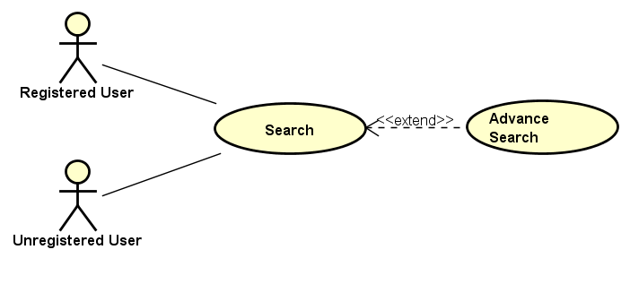

##### Search

|  |  |  |  |  |
| --- | --- | --- | --- | --- |
| Use Case Name | Search | | | |
| Use Case ID | UC-035 | | | |
| Created By | AnhDTL | Last Updated By | | AnhDTL |
| Date Created | 21/09/2015 | Date Last Updated | | 21/09/2015 |
| Actor | Registed User, Unregisted User, Moderator | | | |
| Goal/Description | Allow Actor find out the event and channel which match the inputed text. | | | |
| Pre-Condition | Actor is accessed to the EventZone website. | | | |
| Trigger | Actor navigates to the search bar. | | | |
| Post Condition | Actor is staying on Result screen which has all matching search results. | | | |
|  | Actor’s Action | | System’s Response | |
| Basic Path | 1. Input text to the search bar | | Show event and channel suggestions below the search text field while Actor is typing. | |
| 2.1. Choose once of suggestions | | Redirect to Result screen. | |
| Alternative Paths | 2.2. Search without choose a suggestion. | | Redirect to Result screen. | |
| Exception Paths | 1. If Actor press “Enter” while search bar is empty. | | Show the notice “Let’s fill your text to search !” | |
| Notes |  | | | |

##### Advance Search

|  |  |  |  |  |
| --- | --- | --- | --- | --- |
| Use Case Name | Advance Search | | | |
| Use Case ID | UC-036 | | | |
| Created By | AnhDTL | Last Updated By | | AnhDTL |
| Date Created | 21/09/2015 | Date Last Updated | | 21/09/2015 |
| Actor | Registed User, Unregisted User, Moderator | | | |
| Goal/Description | Allow Actor combine some search conditions to get the best result. | | | |
| Pre-Condition | Actor is accessed to the EventZone website. | | | |
| Trigger | Actor navigates to the Advantage Search. | | | |
| Post Condition | Actor is staying on Result screen which has all matching search results. | | | |
|  | Member’s Action | | System’s Response | |
| Basic Path | 1. Click on the “Advantage search” icon | | Show the “Advantage search” popup | |
| 2. Select on searching conditions checkbox and fill information which actor want. | |  | |
| 3. Click on “Search” button | | Redirect to Result screen | |
| Alternative Paths |  | |  | |
| Exception Paths | 1. Click on | |  | |
| Notes |  | | | |

#### View Event

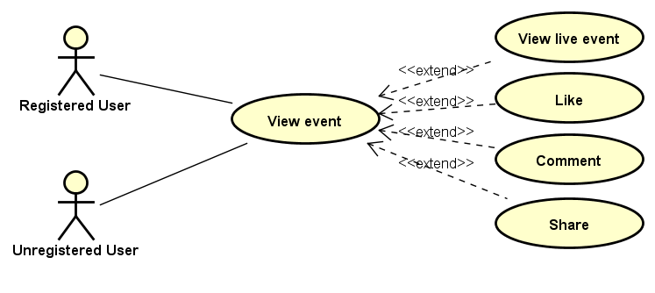

|  |  |  |  |  |  |
| --- | --- | --- | --- | --- | --- |
| Use Case Name | View Event | | | | |
| Use Case ID | UC-037 | | | | |
| Created By | HaNS02665 | Last Updated By | | | HaNS02665 |
| Date Created | 21/9/2015 | Date Last Updated | | | 22/9/2015 |
| Actor | Unregisted User,Registed User,Moderators | | | | |
| Goal/Description | Allow user view event’s information screen | | | | |
| Pre-Condition | System is in “Main Screen” | | | | |
| Trigger | User want to view any event on website | | | | |
| Basic Path | Member’s action | | System response | | |
|  | 1. Click a single event on Video List Screen on MainScreen/ View Channel/Few Detail/Manage Channel/Manage Event | | Redirect to the event screen that contain the chosen fact information | | |
| Alternative Paths |  | |  | | |
| Post Condition | View event Screen is displaying. If exception aruptly end use case, screen will change based on exception paths | | | | |
| Exception Paths | Select “Back” button | | | Redirect to Event List Screen | |
| Notes |  | | | | |

##### View Live Event

|  |  |  |  |  |  |
| --- | --- | --- | --- | --- | --- |
| Use Case Name | View Live Event | | | | |
| Use Case ID | UC-038 | | | | |
| Created By | HaNS02665 | Last Updated By | | | HaNS02665 |
| Date Created | 23/9/2015 | Date Last Updated | | |  |
| Actor | Unregisted User,Registed User,Moderators | | | | |
| Goal/Description | Allow User view live event’s information screen | | | | |
| Pre-Condition | System is in “View Event” Screen | | | | |
| Trigger | User want to view any live event on website. If exception aruptly end use case, screen will change based on exception paths | | | | |
| Basic Path | Member’s action | | System response | | |
|  | 1. Click a single live event on Live Event List Screen | | Redirect to the event screen that contain the chosen fact information | | |
| Alternative Paths |  | |  | | |
| Post Condition | View Live Event Screen is displaying. | | | | |
| Exception Paths | Select “Back” button | | | Redirect to Live Event List Screen | |
| Notes |  | | | | |

##### Like

|  |  |  |  |  |
| --- | --- | --- | --- | --- |
| Use Case Name | Like Event | | | |
| Use Case ID | UC-039 | | | |
| Created By | HaNS02665 | Last Updated By | | HaNS02665 |
| Date Created | 21/9/2015 | Date Last Updated | | 22/9/2015 |
| Actor | Unregisted User,Registed User,Moderators | | | |
| Goal/Description | Allow user like to event | | | |
| Pre-Condition | System is in “View Event” screeen | | | |
| Trigger | User want to “like” any event on website | | | |
| Basic Path | Member’s action | | System response | |
|  | 1. Click on “Like” tab | | Display the number of like will increase with once | |
|  | |  | |
| Alternative Paths |  | |  | |
| Post Condition | System is in “View Event” screen and the number of like will increase with once | | | |
| Exception Paths |  | | | |
| Notes |  | | | |

##### Share

|  |  |  |  |  |
| --- | --- | --- | --- | --- |
| Use Case Name | Share Event | | | |
| Use Case ID | UC-040 | | | |
| Created By | HaNS02665 | Last Updated By | | HaNS02665 |
| Date Created | 22/9/2015 | Date Last Updated | |  |
| Actor | Unregisted User,Registed User,Moderators | | | |
| Goal/Description | Allow user share event | | | |
| Pre-Condition | System is in “View Event” screeen | | | |
| Trigger | User want to share any event on website | | | |
| Basic Path | Member’s action | | System response | |
|  | 1. Click on “facebook” or “google+” or “Twitter” icon share | | Redirect to “Share this event” popup screen | |
|  | 1. Input the status’s content | |  | |
|  | 1. Click on “Share Link” button | | Display “Event is shared sucessfull” message | |
| Alternative Paths | Click on “Cancel” button | | System is in “View Event” screeen and “Share this event” popup is closed | |
| Post Condition | View event Screen is displaying and the number of share will increase with once. If exception aruptly end use case, screen will change based on exception paths | | | |
| Exception Paths |  | | | |
| Notes |  | | | |

##### Comment

|  |  |  |  |  |
| --- | --- | --- | --- | --- |
| Use Case Name | Comment | | | |
| Use Case ID | UC-041 | | | |
| Created By | HaNS02665 | Last Updated By | | HaNS02665 |
| Date Created | 23/9/2015 | Date Last Updated | |  |
| Actor | Unregisted User,Registed User,Moderators | | | |
| Goal/Description | Allow user comment to event | | | |
| Pre-Condition | System is in “View Event” screeen | | | |
| Trigger | User want to “comment” any event on website | | | |
| Basic Path | Member’s action | | System response | |
|  | 1. Click on “Comment” tab | |  | |
| 1. Input user’s comment | |  | |
|  | 1. Click “Send” button | | Update user’comment in the chat box | |
| Alternative Paths |  | |  | |
| Post Condition | System is in “View Event” screen and user’s comment is sent sucessful | | | |
| Exception Paths |  | | | |
| Notes |  | | | |

#### Manage Event

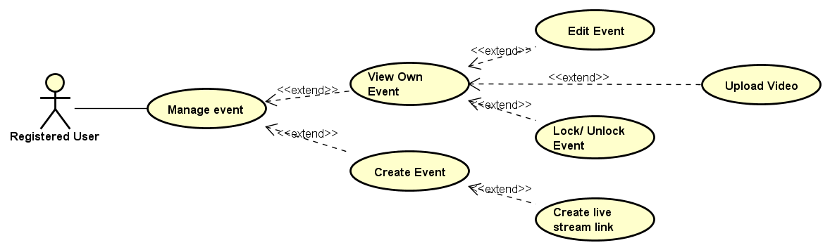

|  |  |  |  |  |
| --- | --- | --- | --- | --- |
| Use Case Name | Manage event | | | |
| Use Case ID | UC-042 | | | |
| Created By | DuongNN | Last Updated By | |  |
| Date Created | 22/09/2015 | Date Last Updated | |  |
| Actor | Registed User | | | |
| Goal/Description | Allow user manage their own created event | | | |
| Pre-Condition | User is at Website screen | | | |
| Trigger | User wants to Manage their event | | | |
| Post Condition | Manage event screen is shown | | | |
| Basic Path | Member’s Action | | System’s Response | |
|  | Click on “Avatar” butotn | | Redirect to Manage Event screen | |
| Alternative Paths |  | |  | |
| Exception Paths |  | |  | |
| Notes | List of User’s events is default for Manage Event screen | | | |

##### View Own Event

|  |  |  |  |  |
| --- | --- | --- | --- | --- |
| Use Case Name | View own event | | | |
| Use Case ID | UC-043 | | | |
| Created By | DuongNN | Last Updated By | |  |
| Date Created | 22/09/2015 | Date Last Updated | |  |
| Actor | Registed User | | | |
| Goal/Description | Allow user view their own created event | | | |
| Pre-Condition | User is at Website Screen | | | |
| Trigger | User wants to view all their event | | | |
| Post Condition | Manage event screen is shown | | | |
| Basic Path | Member’s Action | | System’s Response | |
|  | 1. Click on “Avatar” butotn | | Redirect to Manage event screen | |
| Alternative Paths |  | |  | |
| Exception Paths |  | |  | |
| Notes | List of User’s events is default for Manage Event screen | | | |

##### Create Event

|  |  |  |  |  |
| --- | --- | --- | --- | --- |
| Use Case Name | Create Event | | | |
| Use Case ID | UC-044 | | | |
| Created By | DuongNN | Last Updated By | |  |
| Date Created | 22/09/2015 | Date Last Updated | |  |
| Actor | Registed User | | | |
| Goal/Description | Allow user create an event. | | | |
| Pre-Condition | User is at any Screen | | | |
| Trigger | User wants to create an event. | | | |
| Post Condition | A new event is added sucessfully. | | | |
| Basic Path | Member’s Action | | System’s Response | |
|  | 1. Click on “Create Event” button | | Redirect to Create Event screen. | |
| 1. Fill all required information, add image, add link Video | |  | |
| 1. Click on “Create” button | | Screen will notice: “New Event is created successfully”. Redirect to View Detail Event screen. | |
| Alternative Paths |  | |  | |
| Exception Paths | 1. Click on “Cancel” button | | Redirect to Home screen. | |
| Notes | If there is any required field is empty, screen will notice: “Required fields can’t be empty”.  If there is any field is not match required format, screen will notice: “Please fill valid information”. | | | |

##### Edit Event

|  |  |  |  |  |
| --- | --- | --- | --- | --- |
| Use Case Name | Edit event | | | |
| Use Case ID | UC-045 | | | |
| Created By | DuongNN | Last Updated By | |  |
| Date Created | 22/09/2015 | Date Last Updated | |  |
| Actor | Registed User | | | |
| Goal/Description | Allow user edit events’ information. | | | |
| Pre-Condition | User is at Watch Event Screen | | | |
| Trigger | User wants to Edit their event’s information | | | |
| Post Condition | New information is saved sucessfully | | | |
| Basic Path | Member’s Action | | System’s Response | |
|  | 1. Click on “More” button | | A dropdown group of button is shown | |
| 1. Click on “Edit infomation” butotn | | Redirect to Edit event screen | |
| 1. User fill in new information | |  | |
| 1. Click on “Save” button | | Redirect to View Detail Event screen, screen will show a notice: “New information saved.” | |
| Alternative Paths |  | |  | |
| Exception Paths | 1. Click on “Cancel” button | | Redirect to View Own Event screen | |
| Notes |  | | | |

##### Upload Video

|  |  |  |  |  |
| --- | --- | --- | --- | --- |
| Use Case Name | Upload Video | | | |
| Use Case ID | UC-046 | | | |
| Created By | DuongNN | Last Updated By | |  |
| Date Created | 22/09/2015 | Date Last Updated | |  |
| Actor | Registed User | | | |
| Goal/Description | Allow user upload videos to an event. | | | |
| Pre-Condition | User is at Watch Events Screen (Event Info is default screen) | | | |
| Trigger | User wants to upload videos to an event. | | | |
| Post Condition | Videos added to an event sucessfully. | | | |
| Basic Path | Member’s Action | | System’s Response | |
|  | * 1. Click on “More” button | | A dropdown group of button is shown | |
| * 1. Click on “Upload Video” butotn | | Display Upload Video Popup. | |
| * 1. Click on “Browser” button | | An explore window is shown | |
| * 1. Browse their video User want to upload, click OK. | |  | |
| * 1. Click “Upload” button | | After Video uploaded to server successful, screen will notice: “New Video uploaded successfully”. Redirect to Watch Event screen. | |
| Alternative Paths | 2.1 Click on “Video” Tab. | | Redirect to Video tab | |
|  | * 1. Click on “Upload Video” butotn | | Display Upload Video Popup. | |
|  | * 1. Click on “Browser” button | | An explore window is shown | |
|  | * 1. Browse their video User want to upload, click OK. | |  | |
|  | * 1. Click “Upload” button | | After Video uploaded to server successful, screen will notice: “New Video uploaded successfully”. Redirect to Watch Event screen. | |
| Exception Paths |  | |  | |
| Notes | If there is any internet connection problem, uploading progress is fail. Screen will notice: “Uploading progress is fail”.  If there is no Video is selected when “Upload” button is clicked, Screen will notice: “Please choose a video to upload.” | | | |

##### Create Stream Link

|  |  |  |  |  |
| --- | --- | --- | --- | --- |
| Use Case Name | Create Live Streaming Link | | | |
| Use Case ID | UC-047 | | | |
| Created By | DuongNN | Last Updated By | |  |
| Date Created | 22/09/2015 | Date Last Updated | |  |
| Actor | Registed User | | | |
| Goal/Description | Allow user create an event included Live Streaing Service | | | |
| Pre-Condition | User is at Create Event screen | | | |
| Trigger | User wants to create an event included Live Streaming Video | | | |
| Post Condition | A new Live Streaming Link is created sucessfully. | | | |
| Basic Path | Member’s Action | | System’s Response | |
|  | 1. Check “Use Live Streaming Service” checkbox | | A textbox field is added to contains new Live Streaming Link.  A tutorial popup is shown. Redirect to Create link Screen (belong to YouTube) in new tab. | |
| 1. In the new tab, Follow Steps and the Link is copied. | |  | |
| 1. Click on “Create” button | | Screen will notice: “New Event is created successfully”. Redirect to View Detail Event screen. | |
| Alternative Paths |  | |  | |
| Exception Paths | * 1. Click on “Cancel” button | | Redirect to Home screen. | |
| Notes | If there is any required field is empty, screen will notice: “Required fields can’t be empty”.  If there is any field is not match required format, screen will notice: “Please fill valid information”. | | | |

#### Follow Event

|  |  |  |  |  |
| --- | --- | --- | --- | --- |
| Use Case Name | Follow Event | | | |
| Use Case ID | UC-048 | | | |
| Created By | AnhDTL | Last Updated By | | AnhDTL |
| Date Created | 21/09/2015 | Date Last Updated | | 21/09/2015 |
| Actor | Registed User, Moderator | | | |
| Goal/Description | Allow Actor follow the event to easy to get notification about them. | | | |
| Pre-Condition | Actor is staying on “View Event” or “Few Detail” screens. | | | |
| Trigger | Actor navigates to Follow others. | | | |
| Post Condition | Actor still staying on “View Event” or “Few Detail” screens. | | | |
|  | Member’s Action | | System’s Response | |
| Basic Path | 1. Click on the “Follow” button | | “Follow” button will be change to “Followed” button. | |
| Alternative Paths |  | |  | |
| Exception Paths |  | |  | |
| Notes |  | | | |

#### Follow Category

|  |  |  |  |  |
| --- | --- | --- | --- | --- |
| Use Case Name | Follow Category | | | |
| Use Case ID | UC-049 | | | |
| Created By | AnhDTL | Last Updated By | | AnhDTL |
| Date Created | 21/09/2015 | Date Last Updated | | 21/09/2015 |
| Actor | Registed User, Moderator | | | |
| Goal/Description | Allow Actor follow the category to easy to see a group of related event. | | | |
| Pre-Condition | Actor is staying on Main screen. | | | |
| Trigger | Actor navigates to Follow Categorys. | | | |
| Post Condition | Actor still staying on Main screen. | | | |
|  | Member’s Action | | System’s Response | |
| Basic Path | 1. Mouse hover on any “Category” button | | Show a box include a “Follow” button and some statistic. | |
|  | 2. Click on “Follow” button. | | Change “Follow” button to “Followed” button. | |
| Alternative Paths |  | |  | |
| Exception Paths | 2. 2. Mouse move to outside the box and “Category” button. | | Disappear the box. | |
| Notes |  | | | |

#### Manage Profile

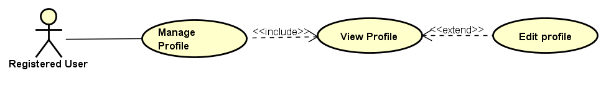

##### View Profile

|  |  |  |  |  |
| --- | --- | --- | --- | --- |
| Use Case Name | View Profile | | | |
| Use Case ID | UC-050 | | | |
| Created By | AnhDTL | Last Updated By | | AnhDTL |
| Date Created | 21/09/2015 | Date Last Updated | | 21/09/2015 |
| Actor | Registed User, Moderator | | | |
| Goal/Description | Actor can view profile’s information. | | | |
| Pre-Condition | Actor is staying on any screen of EventZone website. | | | |
| Trigger | Actor navigates to view profile. | | | |
| Post Condition | Actor is staying in “Manage Profile” screen. | | | |
|  | Member’s Action | | System’s Response | |
| Basic Path | 1. Click on avatar icon | | Redirect to the “Manage profile” screen. | |
| Alternative Paths |  | |  | |
| Exception Paths |  | |  | |
| Notes | “View profile” tab is a default tab on “Manage profile” screen. | | | |

##### Edit Profile

|  |  |  |  |  |
| --- | --- | --- | --- | --- |
| Use Case Name | Edit Profile | | | |
| Use Case ID | UC-051 | | | |
| Created By | AnhDTL | Last Updated By | | AnhDTL |
| Date Created | 21/09/2015 | Date Last Updated | | 21/09/2015 |
| Actor | Registed User, Moderator | | | |
| Goal/Description | System allow actor to edit profile’s information. | | | |
| Pre-Condition | Actor is staying on“User Info” tab of Manage Profile screen. | | | |
| Trigger | Actor navigates to edit and update profile. | | | |
| Post Condition | Actor is staying on “User Info” tab of Manage Profile screen. | | | |
|  | Member’s Action | | System’s Response | |
| Basic Path | 1. Click on “Edit” button. | | “Edit” button will change to “Save” button and “Cancel” button will appear. | |
| 2. Actor fill or edit information. | |  | |
| 3.1. Click on “Save” button. | | “Save” button will change to “Edit” button and “Cancel” button will disappear. | |
| Alternative Paths |  | |  | |
| Exception Paths | 3.2. Click on “Cancel” button. | | Return to “User Info” tab. | |
| Notes | “User Info” is a default tab of Manage profile screen. | | | |

#### Report Event

|  |  |  |  |  |
| --- | --- | --- | --- | --- |
| Use Case Name | Report Event | | | |
| Use Case ID | UC-052 | | | |
| Created By | AnhDTL | Last Updated By | | AnhDTL |
| Date Created | 21/09/2015 | Date Last Updated | | 21/09/2015 |
| Actor | Registed User, Moderator | | | |
| Goal/Description | System allow Actor to report other’s event. | | | |
| Pre-Condition | Actor is staying on “View Event” screen. | | | |
| Trigger | Actor navigates to report other’s event. | | | |
| Post Condition | Actor is staying in “View Event” screen | | | |
|  | Member’s Action | | System’s Response | |
| Basic Path | 1. Click on “Report” tab | | Display the report tab include provided reason . | |
|  | 2.1. Select reasons | |  | |
|  | 3. Click on “Report” button. | | “Report” button will be disabled. And show a notice “Submited successfully”. | |
| Alternative Paths |  | |  | |
| Exception Paths |  | |  | |
| Notes |  | | | |

#### Appeal

|  |  |  |  |  |
| --- | --- | --- | --- | --- |
| Use Case Name | Appeal | | | |
| Use Case ID | UC-053 | | | |
| Created By | AnhDTL | Last Updated By | | AnhDTL |
| Date Created | 21/09/2015 | Date Last Updated | | 21/09/2015 |
| Actor | Registed User, Moderator | | | |
| Goal/Description | Allow Actor appeal other’s report. | | | |
| Pre-Condition | Actor is staying on “Manage Event” tab of Manage Channel screen. | | | |
| Trigger | Actor navigates to appeal other’s report. | | | |
| Post Condition | Actor is staying on “Manage Event” tab of Manage Channel screen. | | | |
|  | Member’s Action | | System’s Response | |
| Basic Path | 1. Click on “Appeal” icon beside event’s thumbnail, which be reported. | | Display the “Appeal” popup. | |
|  | 2. Fill the appeal reason for each report. | |  | |
|  | 3. Click on “Done” button. | | Display “Manage Event” tab. | |
| Alternative Paths |  | |  | |
| Exception Paths |  | |  | |
| Notes | “Manage Event” tab show list event of Actor. | | | |

## Usability

* Interface should be simple, easy-to-use, clear
* Color should be gentle
* Take maximum 30 minutes for normal user to become productive at particular operations
* Take maximum 1 hour 30 minutes for user to learn streaming video
* User can understand approximately 90% help/error messages

## Reliability

* Availability:
  + Of server: 160/168 hours every week
  + Of website: 160/168 hours every week
* Mean Time Between Failures (MTBF): Expected to be approximately 500 hours.
* Mean Time To Repair (MTTR): System is allowed to be out of operation at most 12 hours after it has failed
* Maximum Bugs or Defect Rate: 2 bugs/a function
* Database must be backed up daily for recovering if neccessary
* Search Result return must be correctly
* Location of event is corrected approximately 95%
* Reports and Appeals will be checked in at most 12 hours since submitted time by moderators/admins

## Performance

* Response Time:
  + Time for searching: At most 10s
  + Time for loading image: At most 5s
  + Time to progress any function: will not exceed 7 seconds

## Supportability

* Coding Standards and Naming Conventions
  + All code must be clearly commented, including class, method documentations
  + If some components are reused, the documentations of those components must also be included
* Design
  + Loosely coupled that chances on some modules can’t affect others
* Logging
  + Errors must be signed to support maintain and fixing bug.
  + All sensitive situations must be signed

## Design Constraints

* Software Languages: C# MVC Model
* Software Process Model: Iterative Model
* Developmental Tools: Visual Studio 2013
* Database Tools: SQL Server 2012

## Interface

* + 1. User Interface

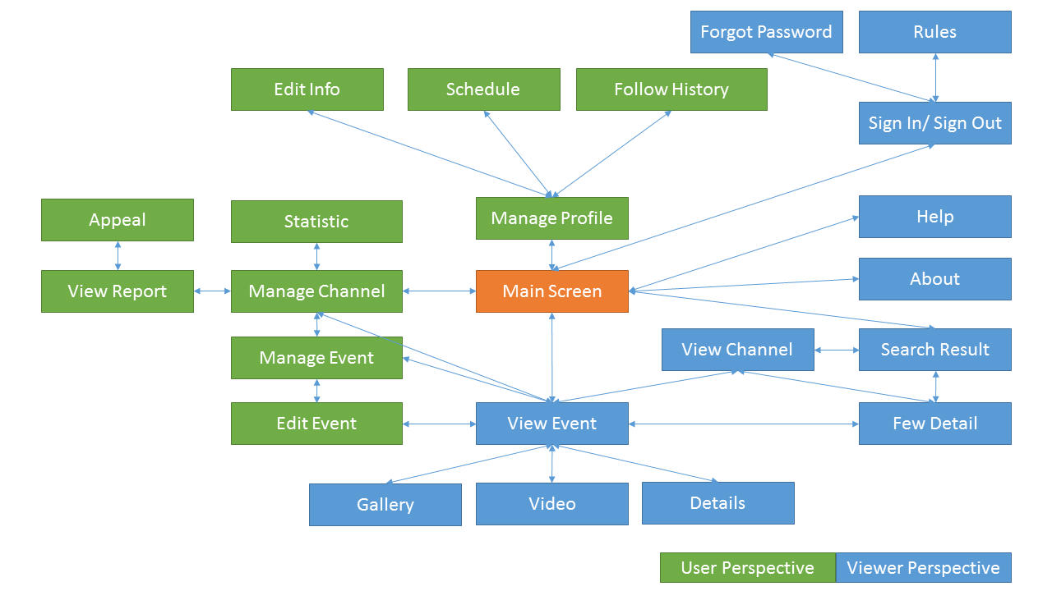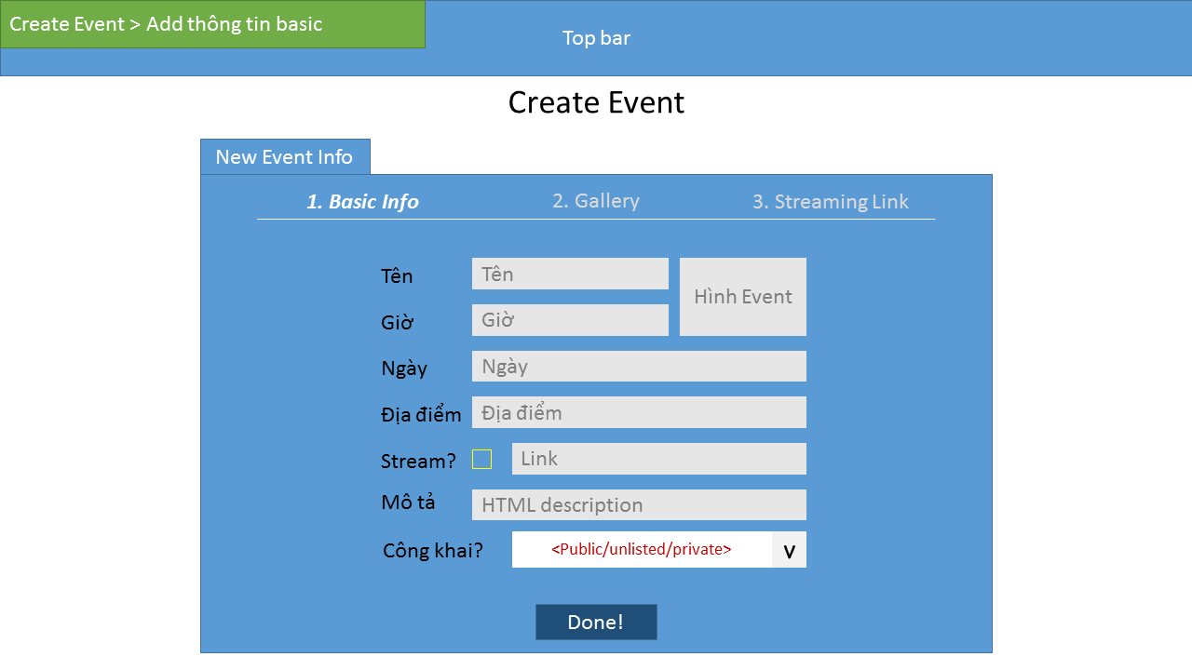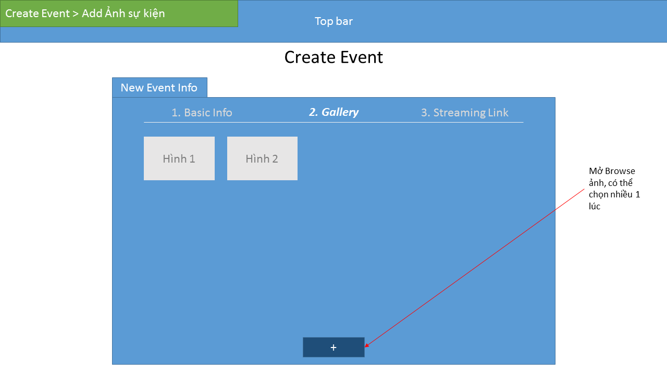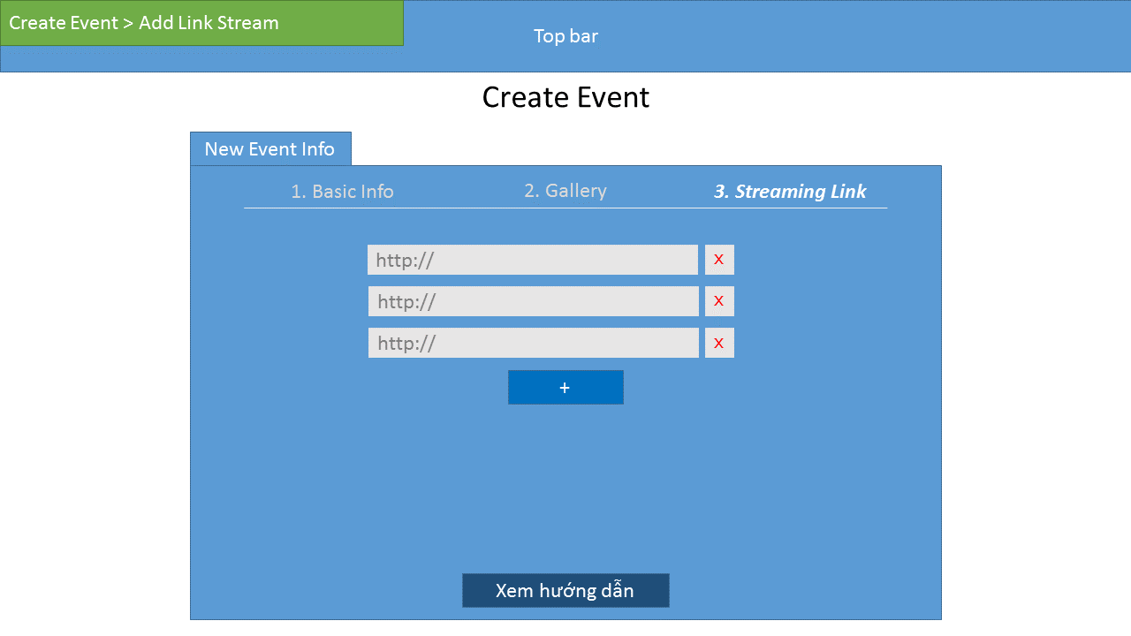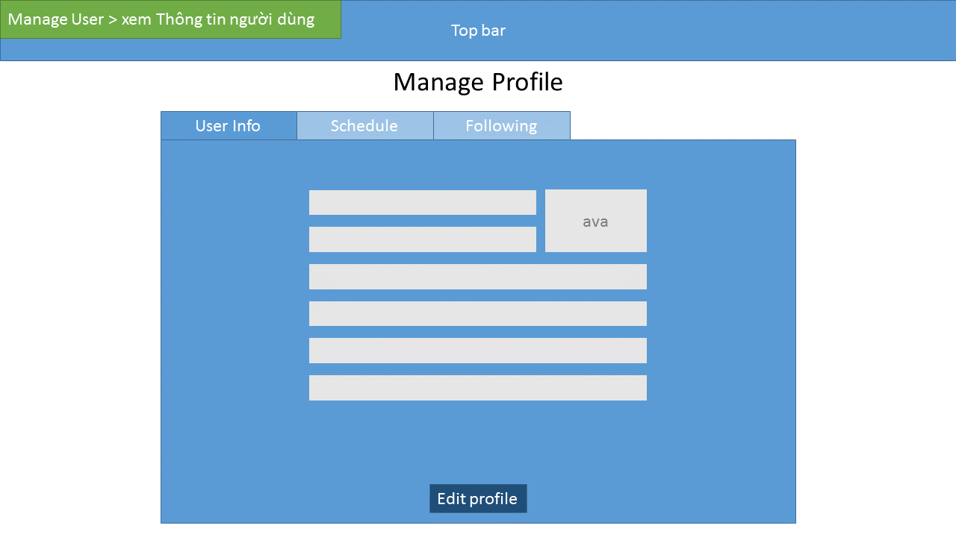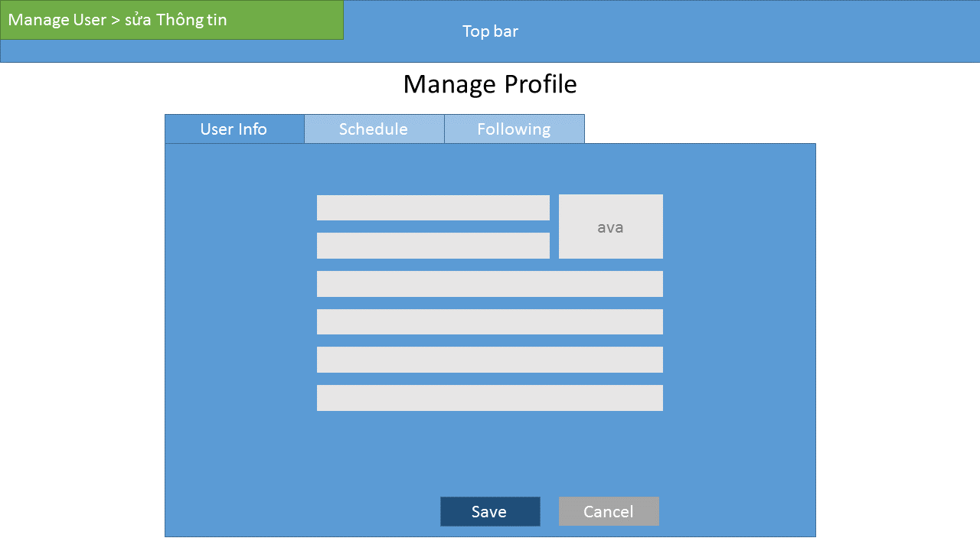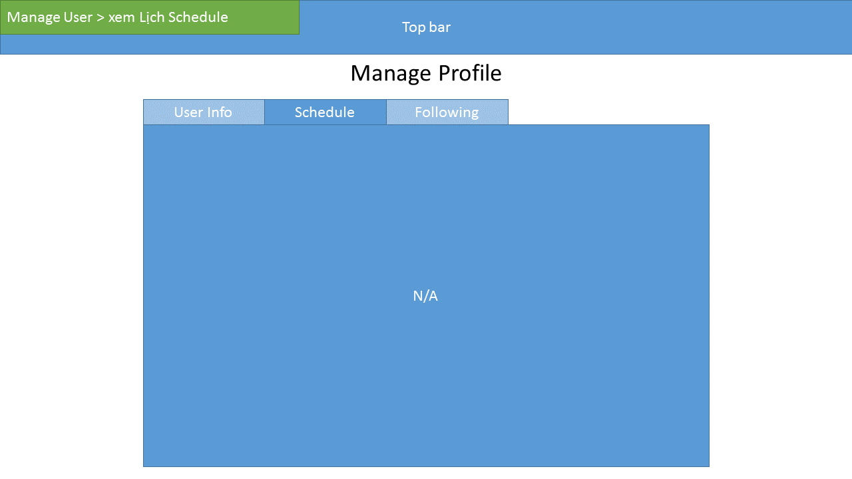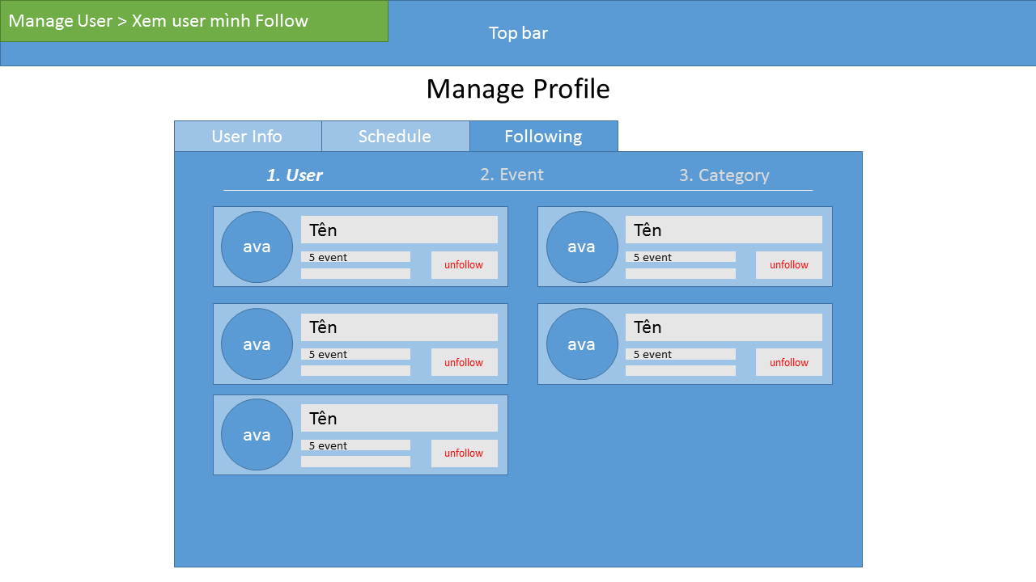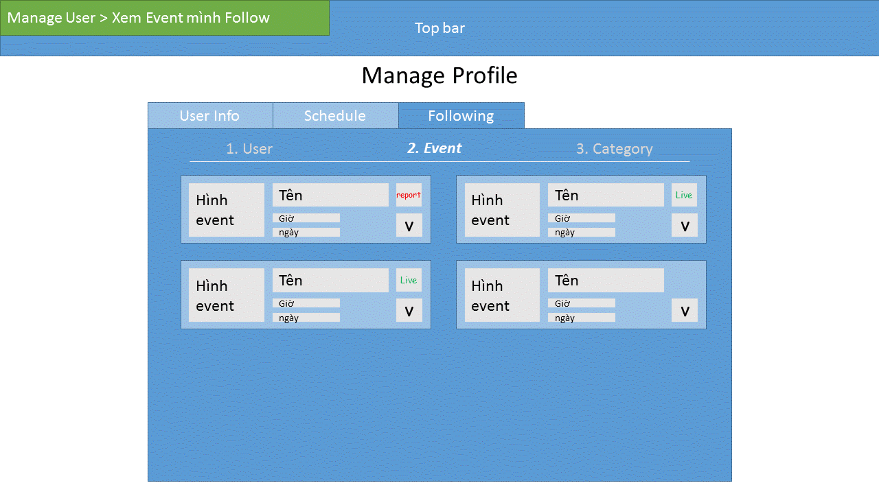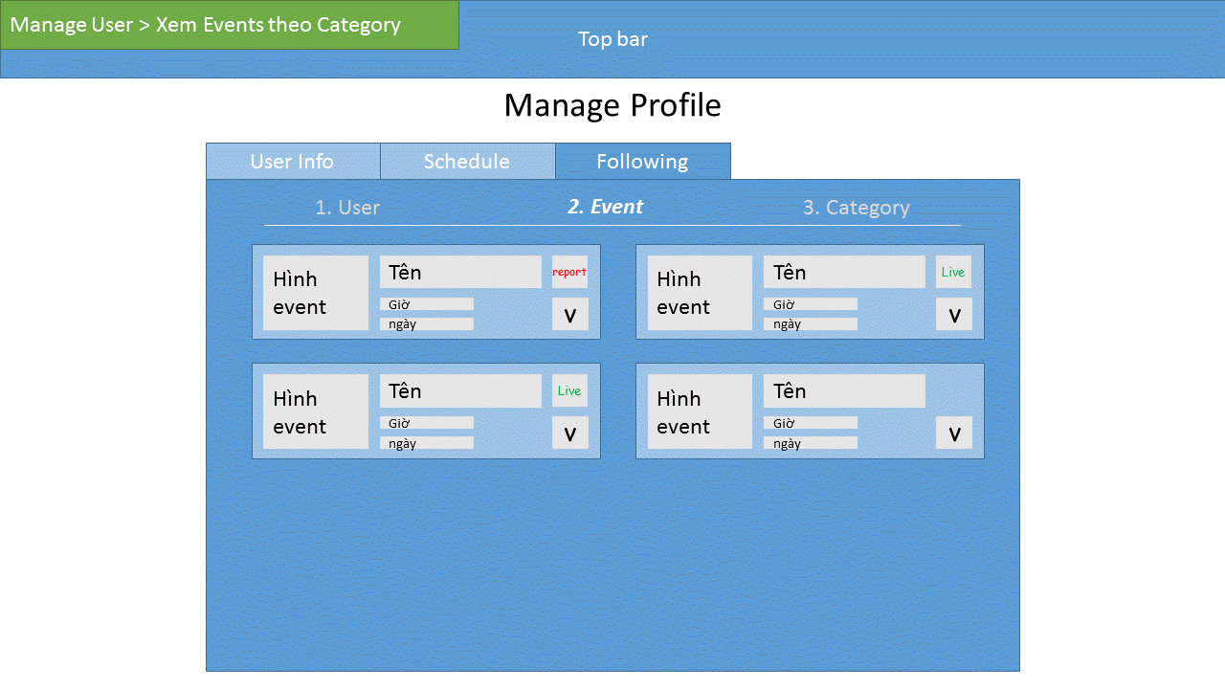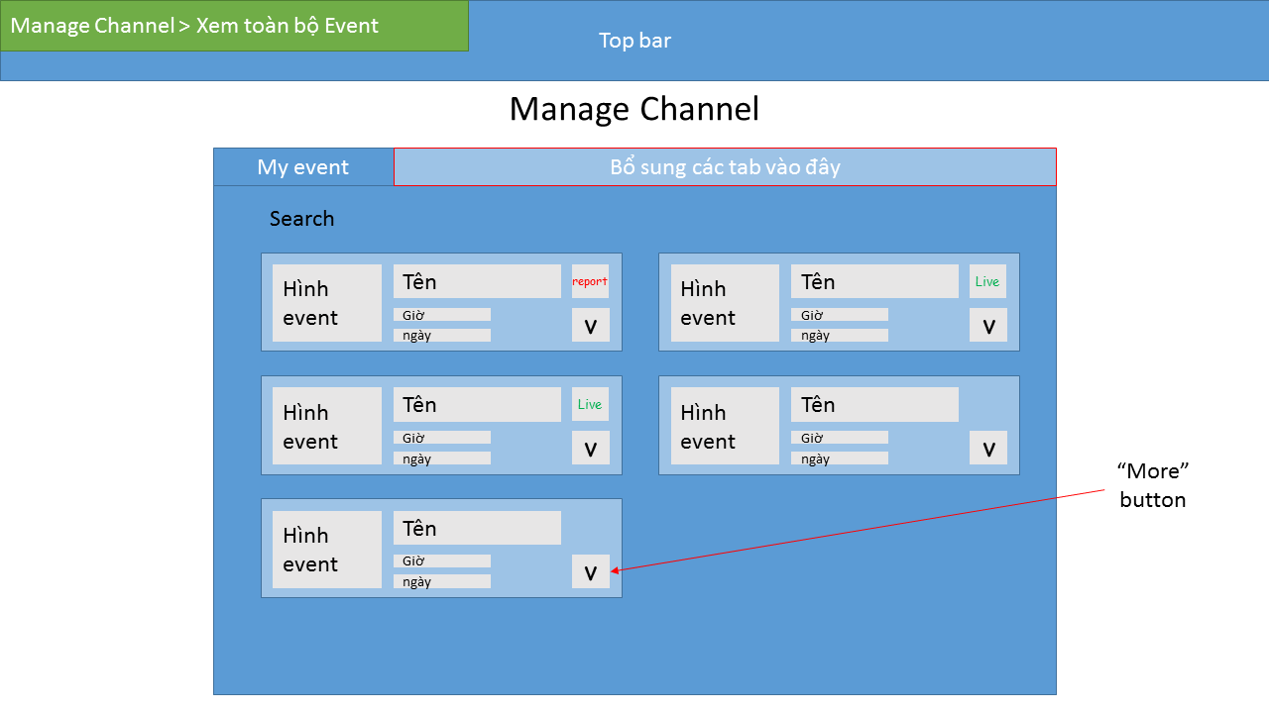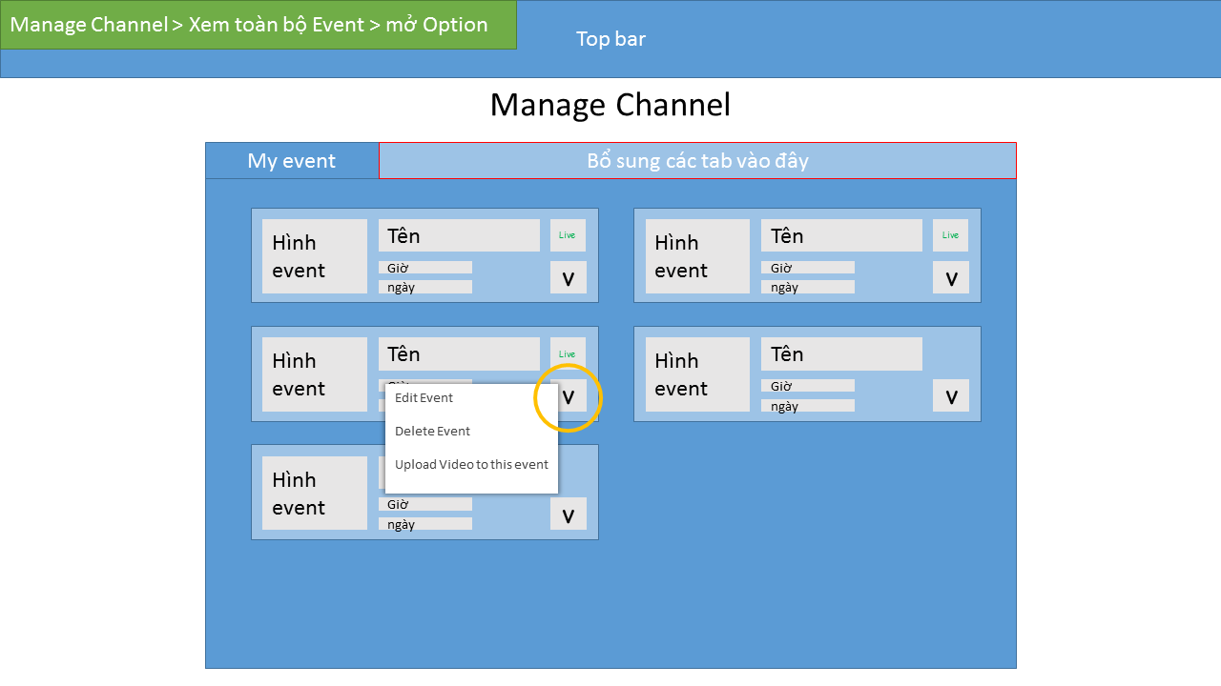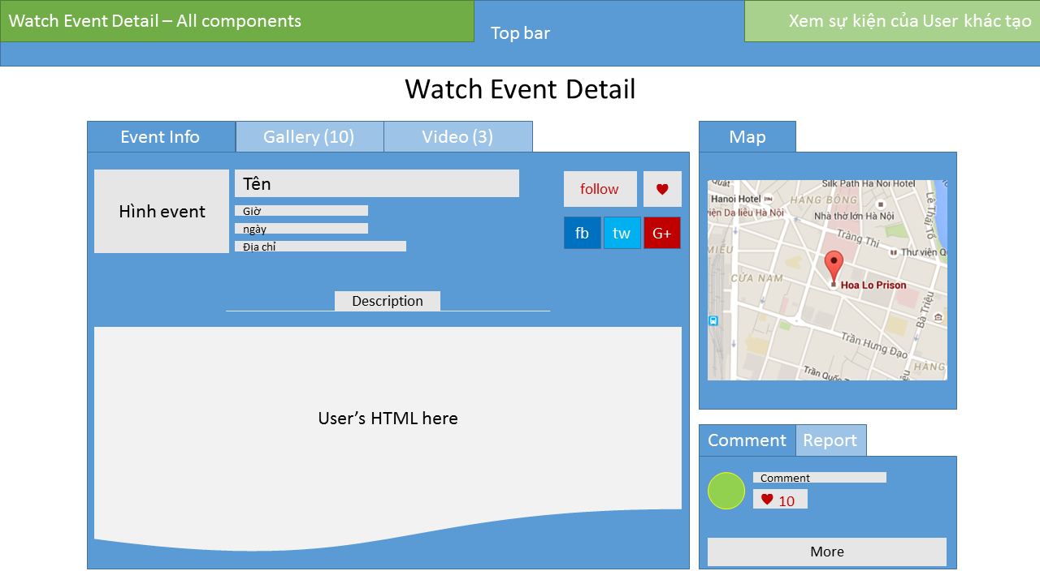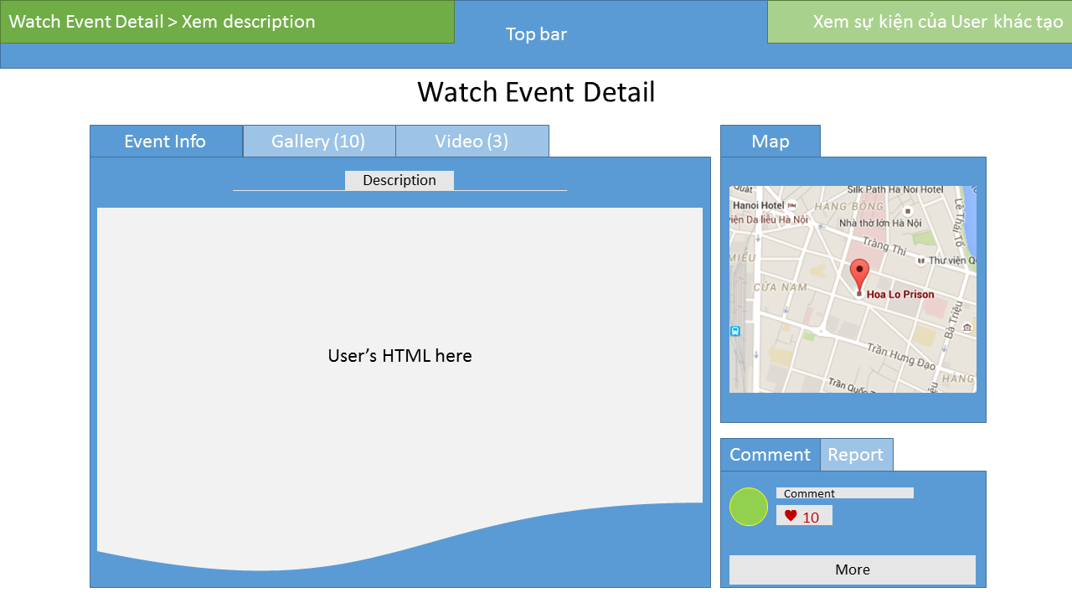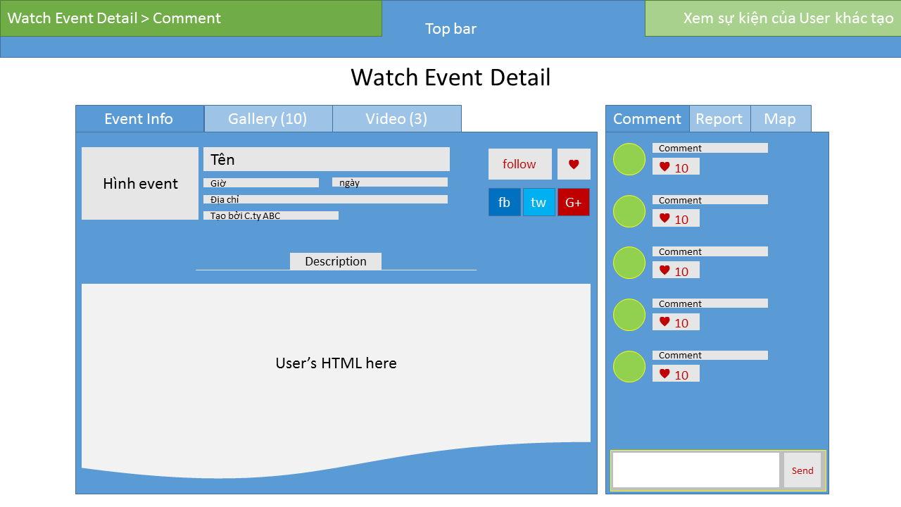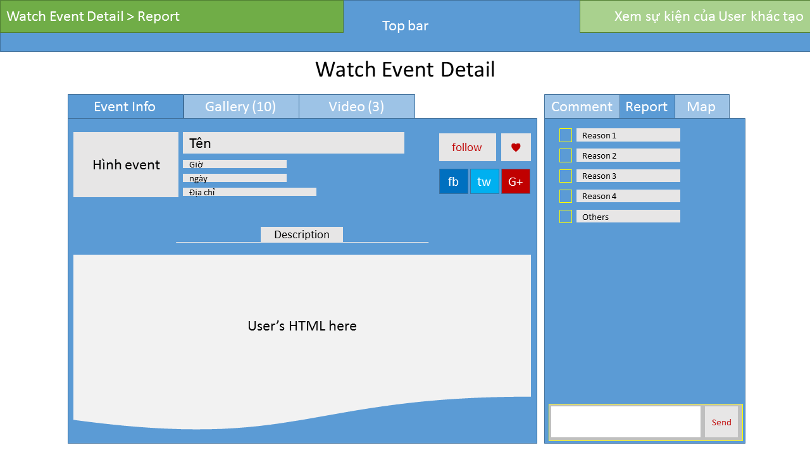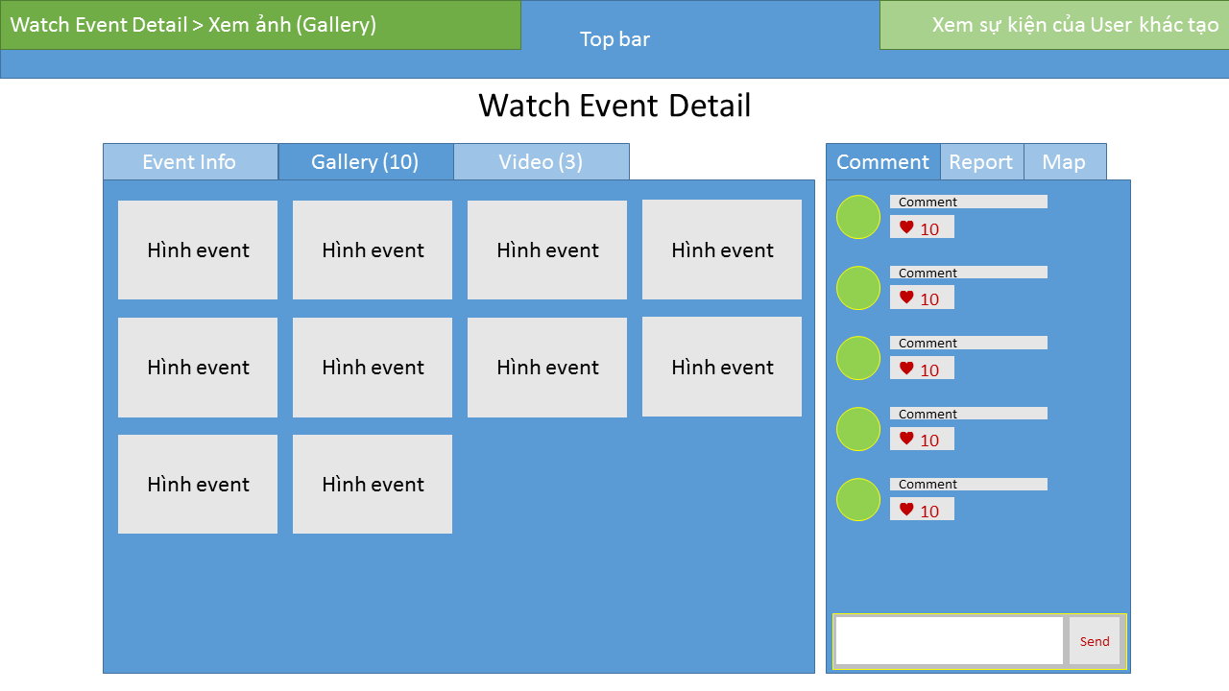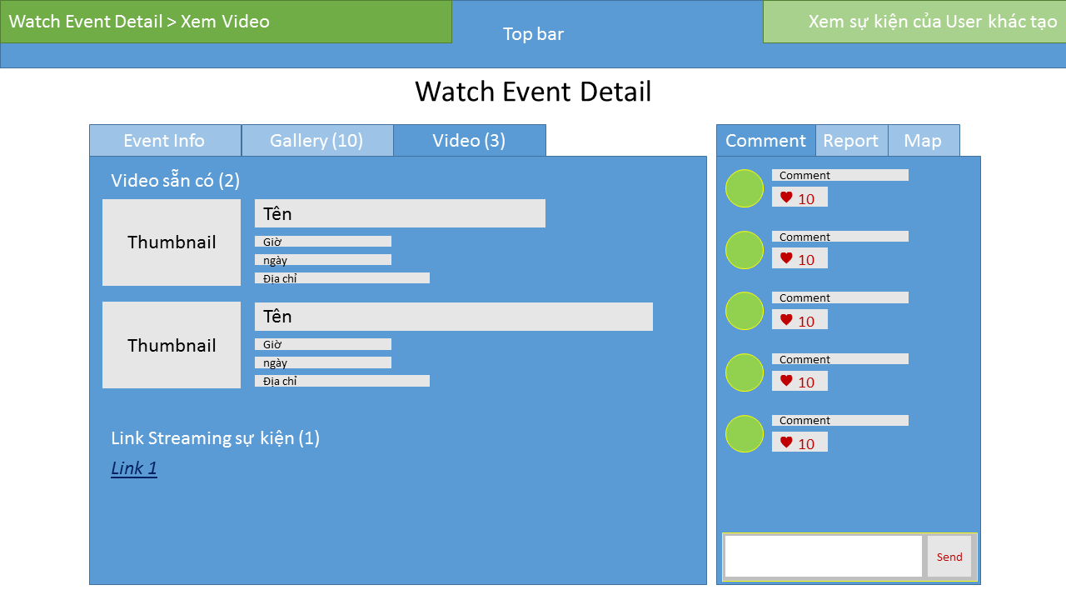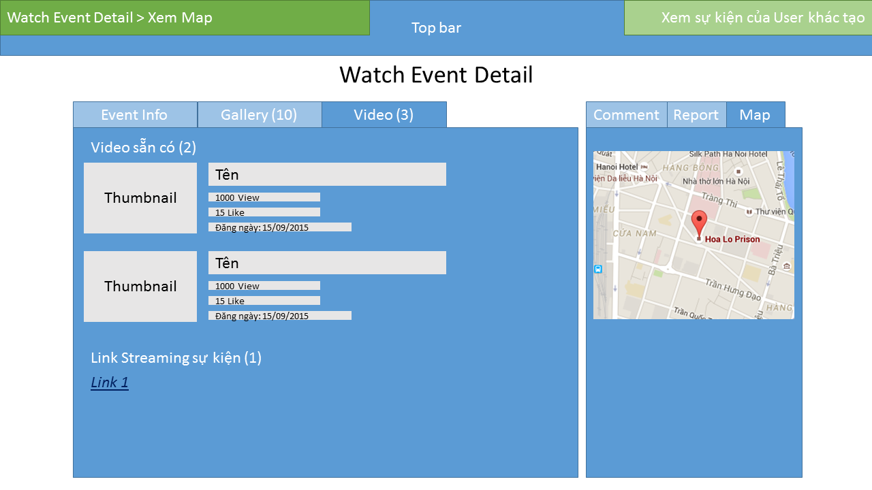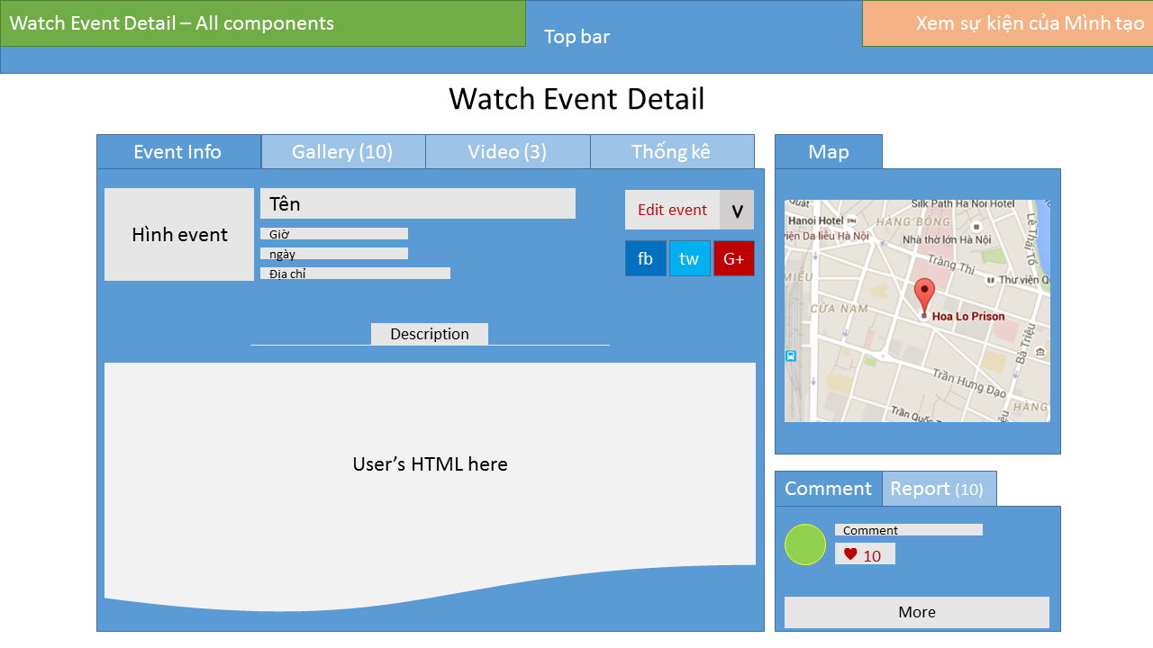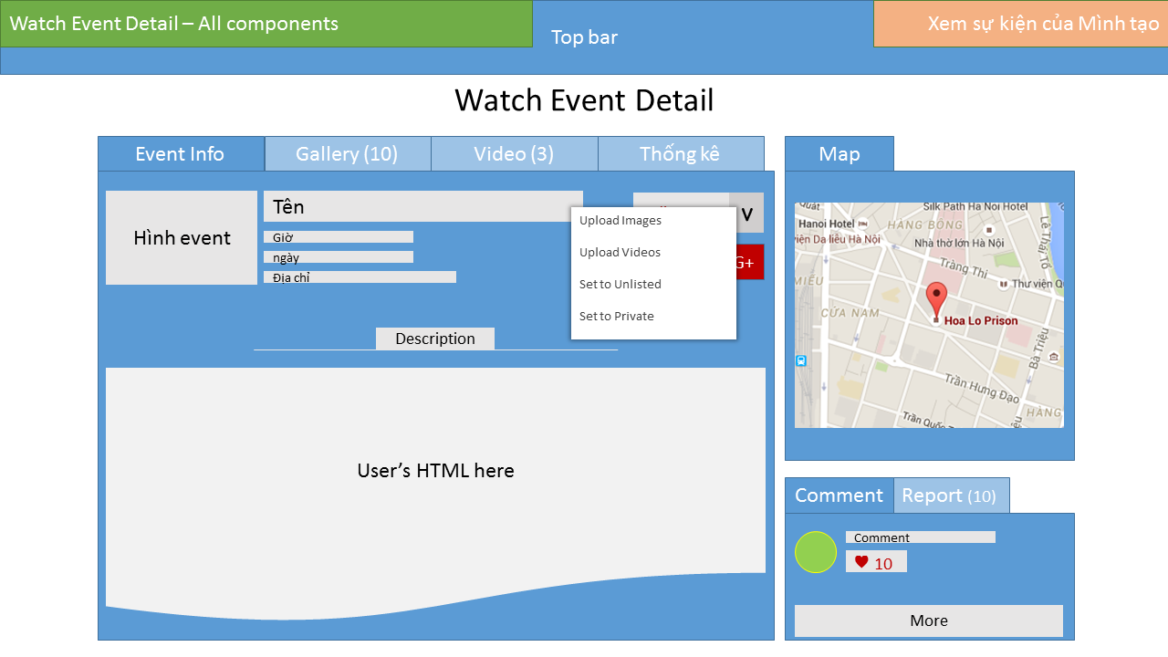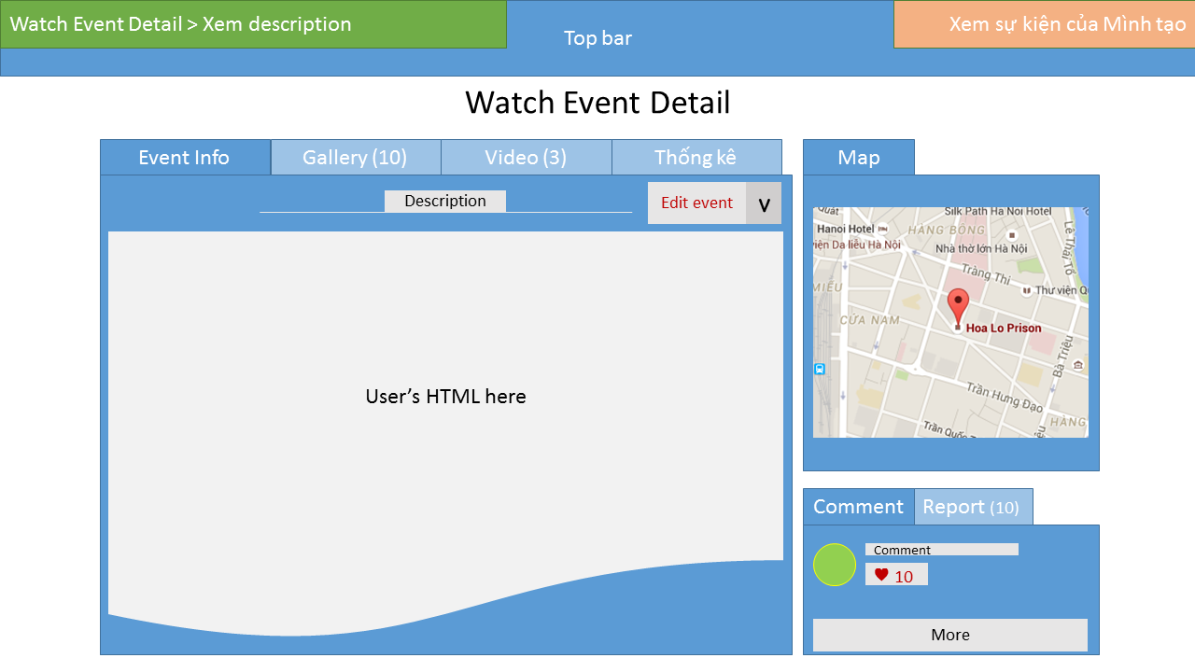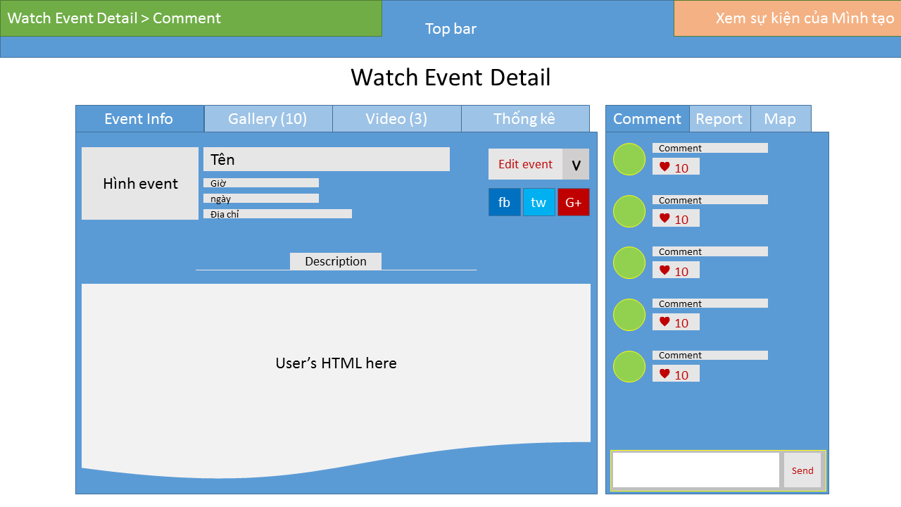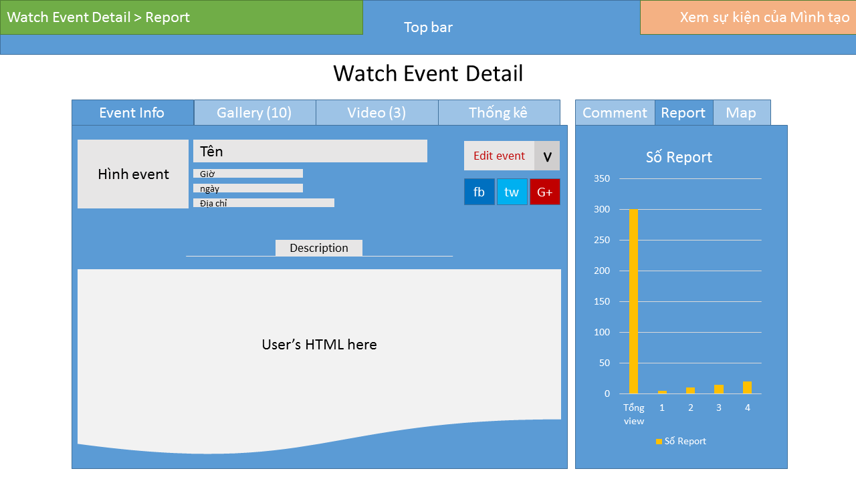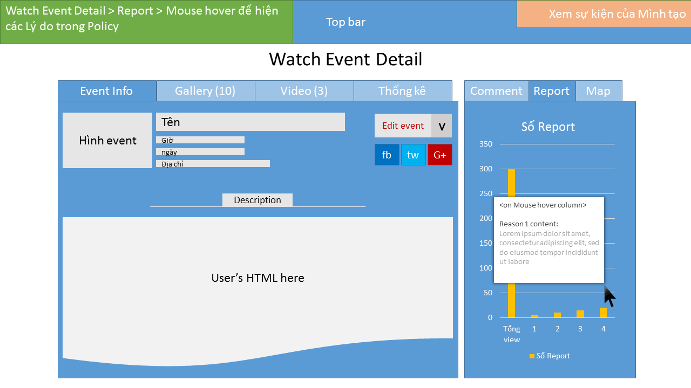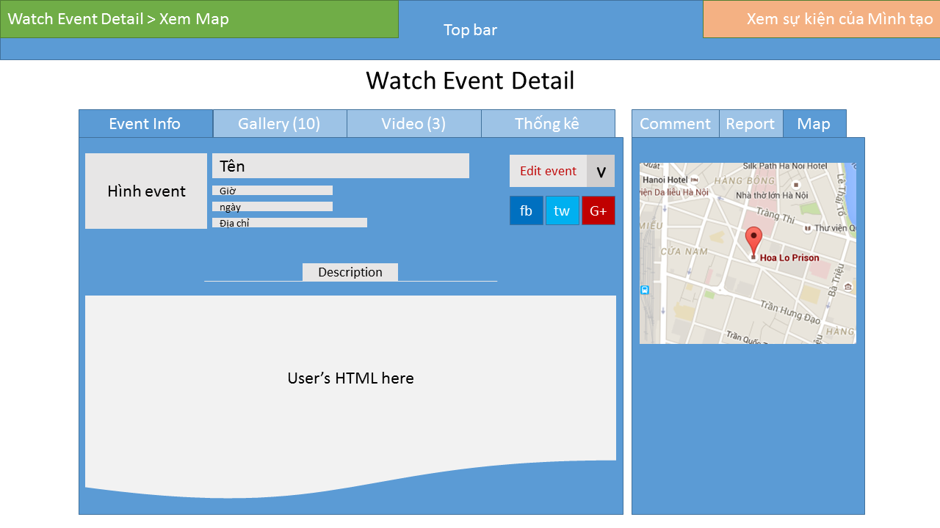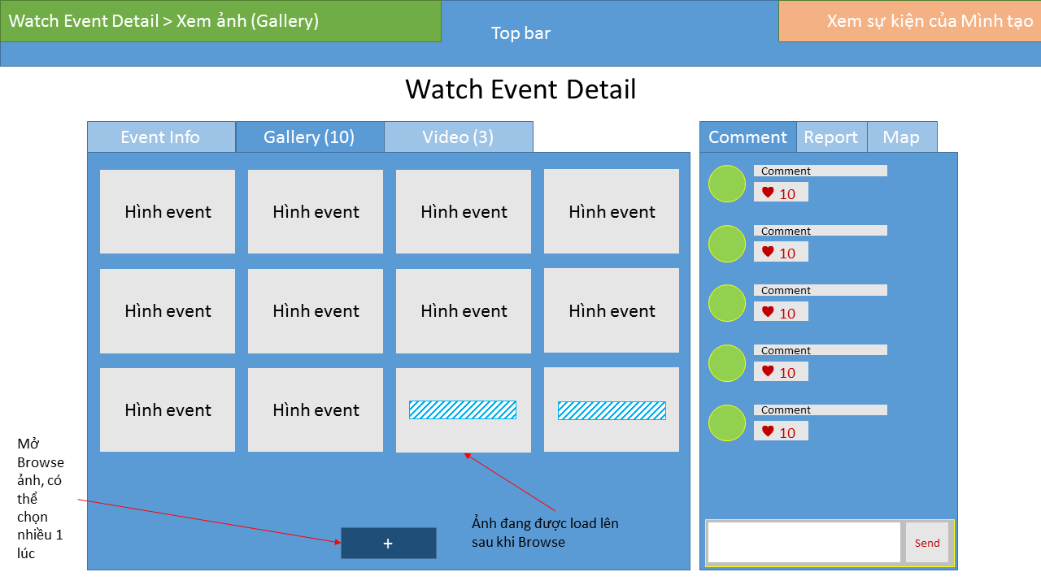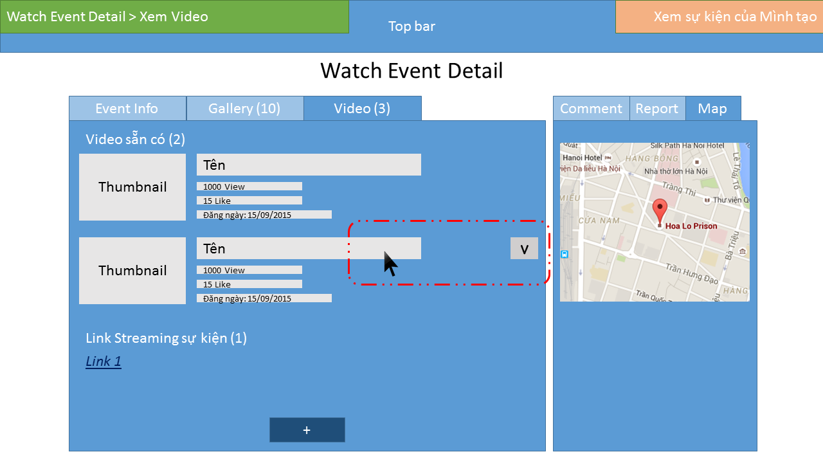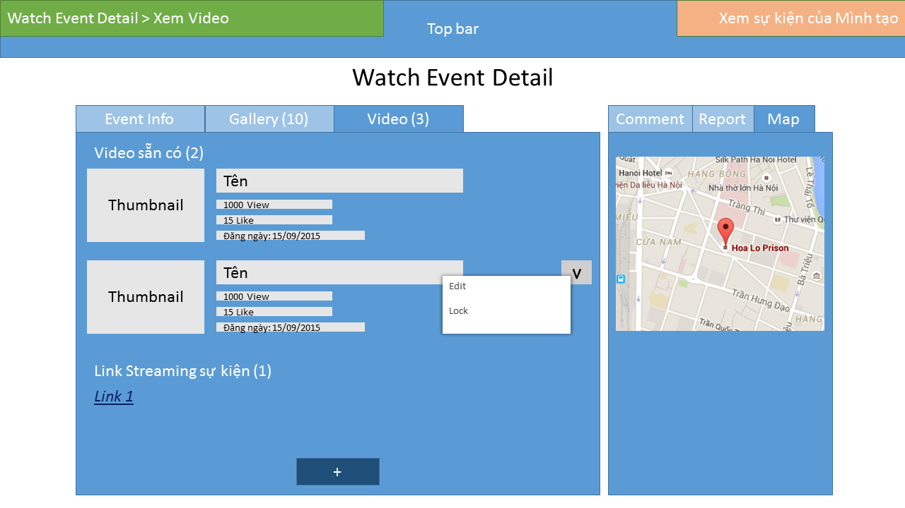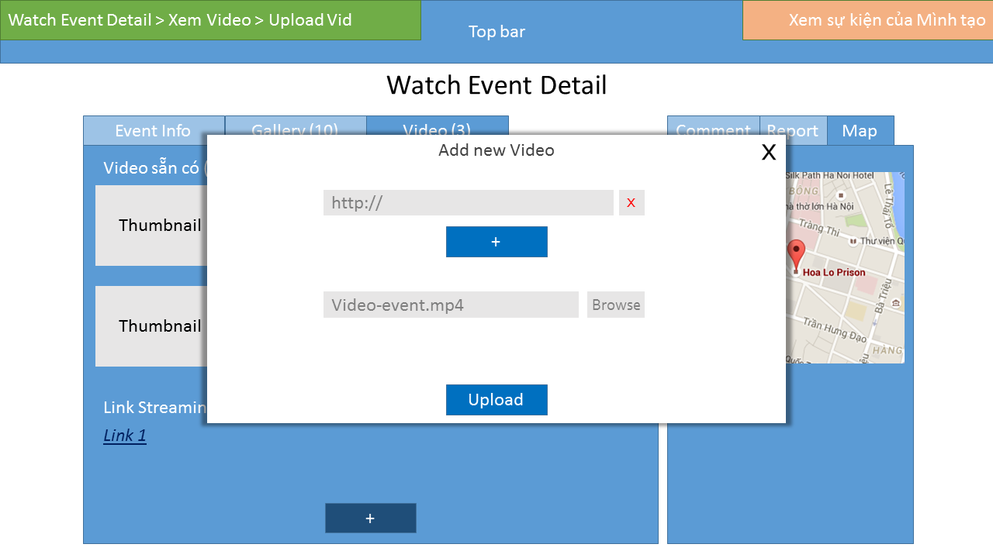

# Support information

N/A